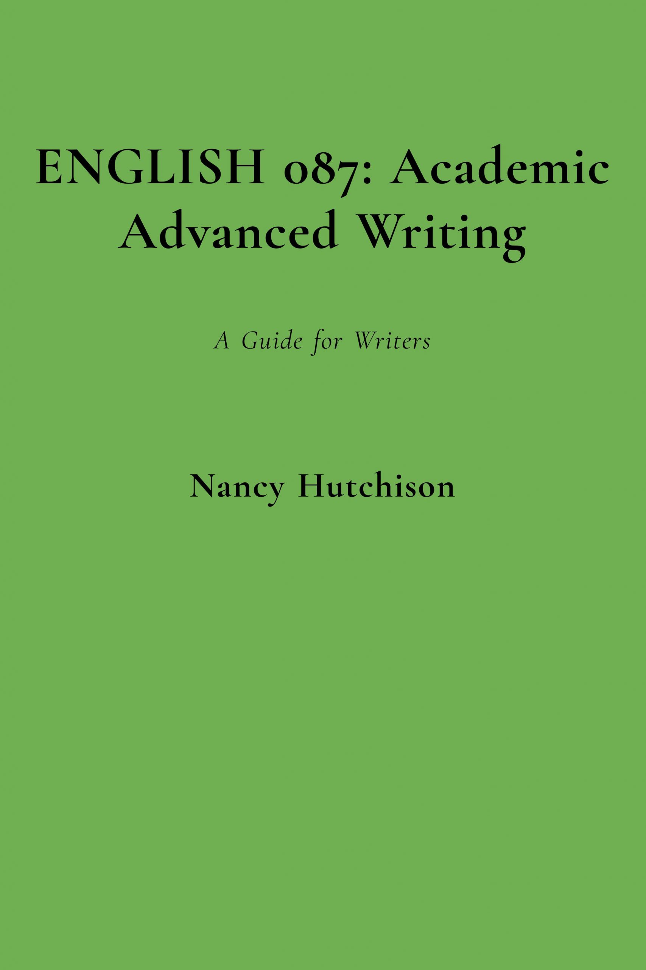

ENGLISH 087: Academic Advanced Writing

ENGLISH 087: Academic Advanced Writing

A Guide for Writers

Nancy Hutchison

ENGLISH 087: Academic Advanced Writing by Nancy Hutchison is licensed under a Creative Commons Attribution-NonCommercial-ShareAlike 4.0 International License, except where otherwise noted.

Contents
- Preface & Acknowledgements
- Welcome
- Writing to Create Change
- Before You Write
- Audience, Purpose, & Context
- Recursive Writing Process
- Strategies for Getting Started
Carol Burnell, Jaime Wood, Monique Babin, Susan Pesznecker, and Nicole Rosevear
- Academic Honesty
- Summarizing
- Using Paraphrases & Quotations
- In-text Citations & Works Cited Pages ~ MLA Format
- Avoiding Plagiarism
- Writing Advice
- Unity & Coherence
- Paragraphs ~ Topic Sentences
- Topic Sentences ~ More Examples
- Paragraphs ~ Developing Support
- Transitions
- Transition Words & Phrases ~ Useful Lists
- Rhetorical Modes for Paragraphs & Essays
- Essays ~ Choosing the Best Structure
- Introductions & Titles
- Conclusions
- Argument, Counterargument, & Refutation
- Ethos, Pathos, & Logos
- Big Issues
- Metacognition
- Information Literacy: Evaluating Information
- Critical Thinking for Academic Writing in the U.S.
- Appendices
- Keyboarding Practice Sites
- MLA Formatting Guides
- Glossary

Preface & Acknowledgements
This text is intended for students and instructors of Academic Advanced Writing for English Language Learners. Support for this Open Educational Resource was provided as a portion of a sabbatical project by Howard Community College in Columbia, Maryland, USA.

Welcome

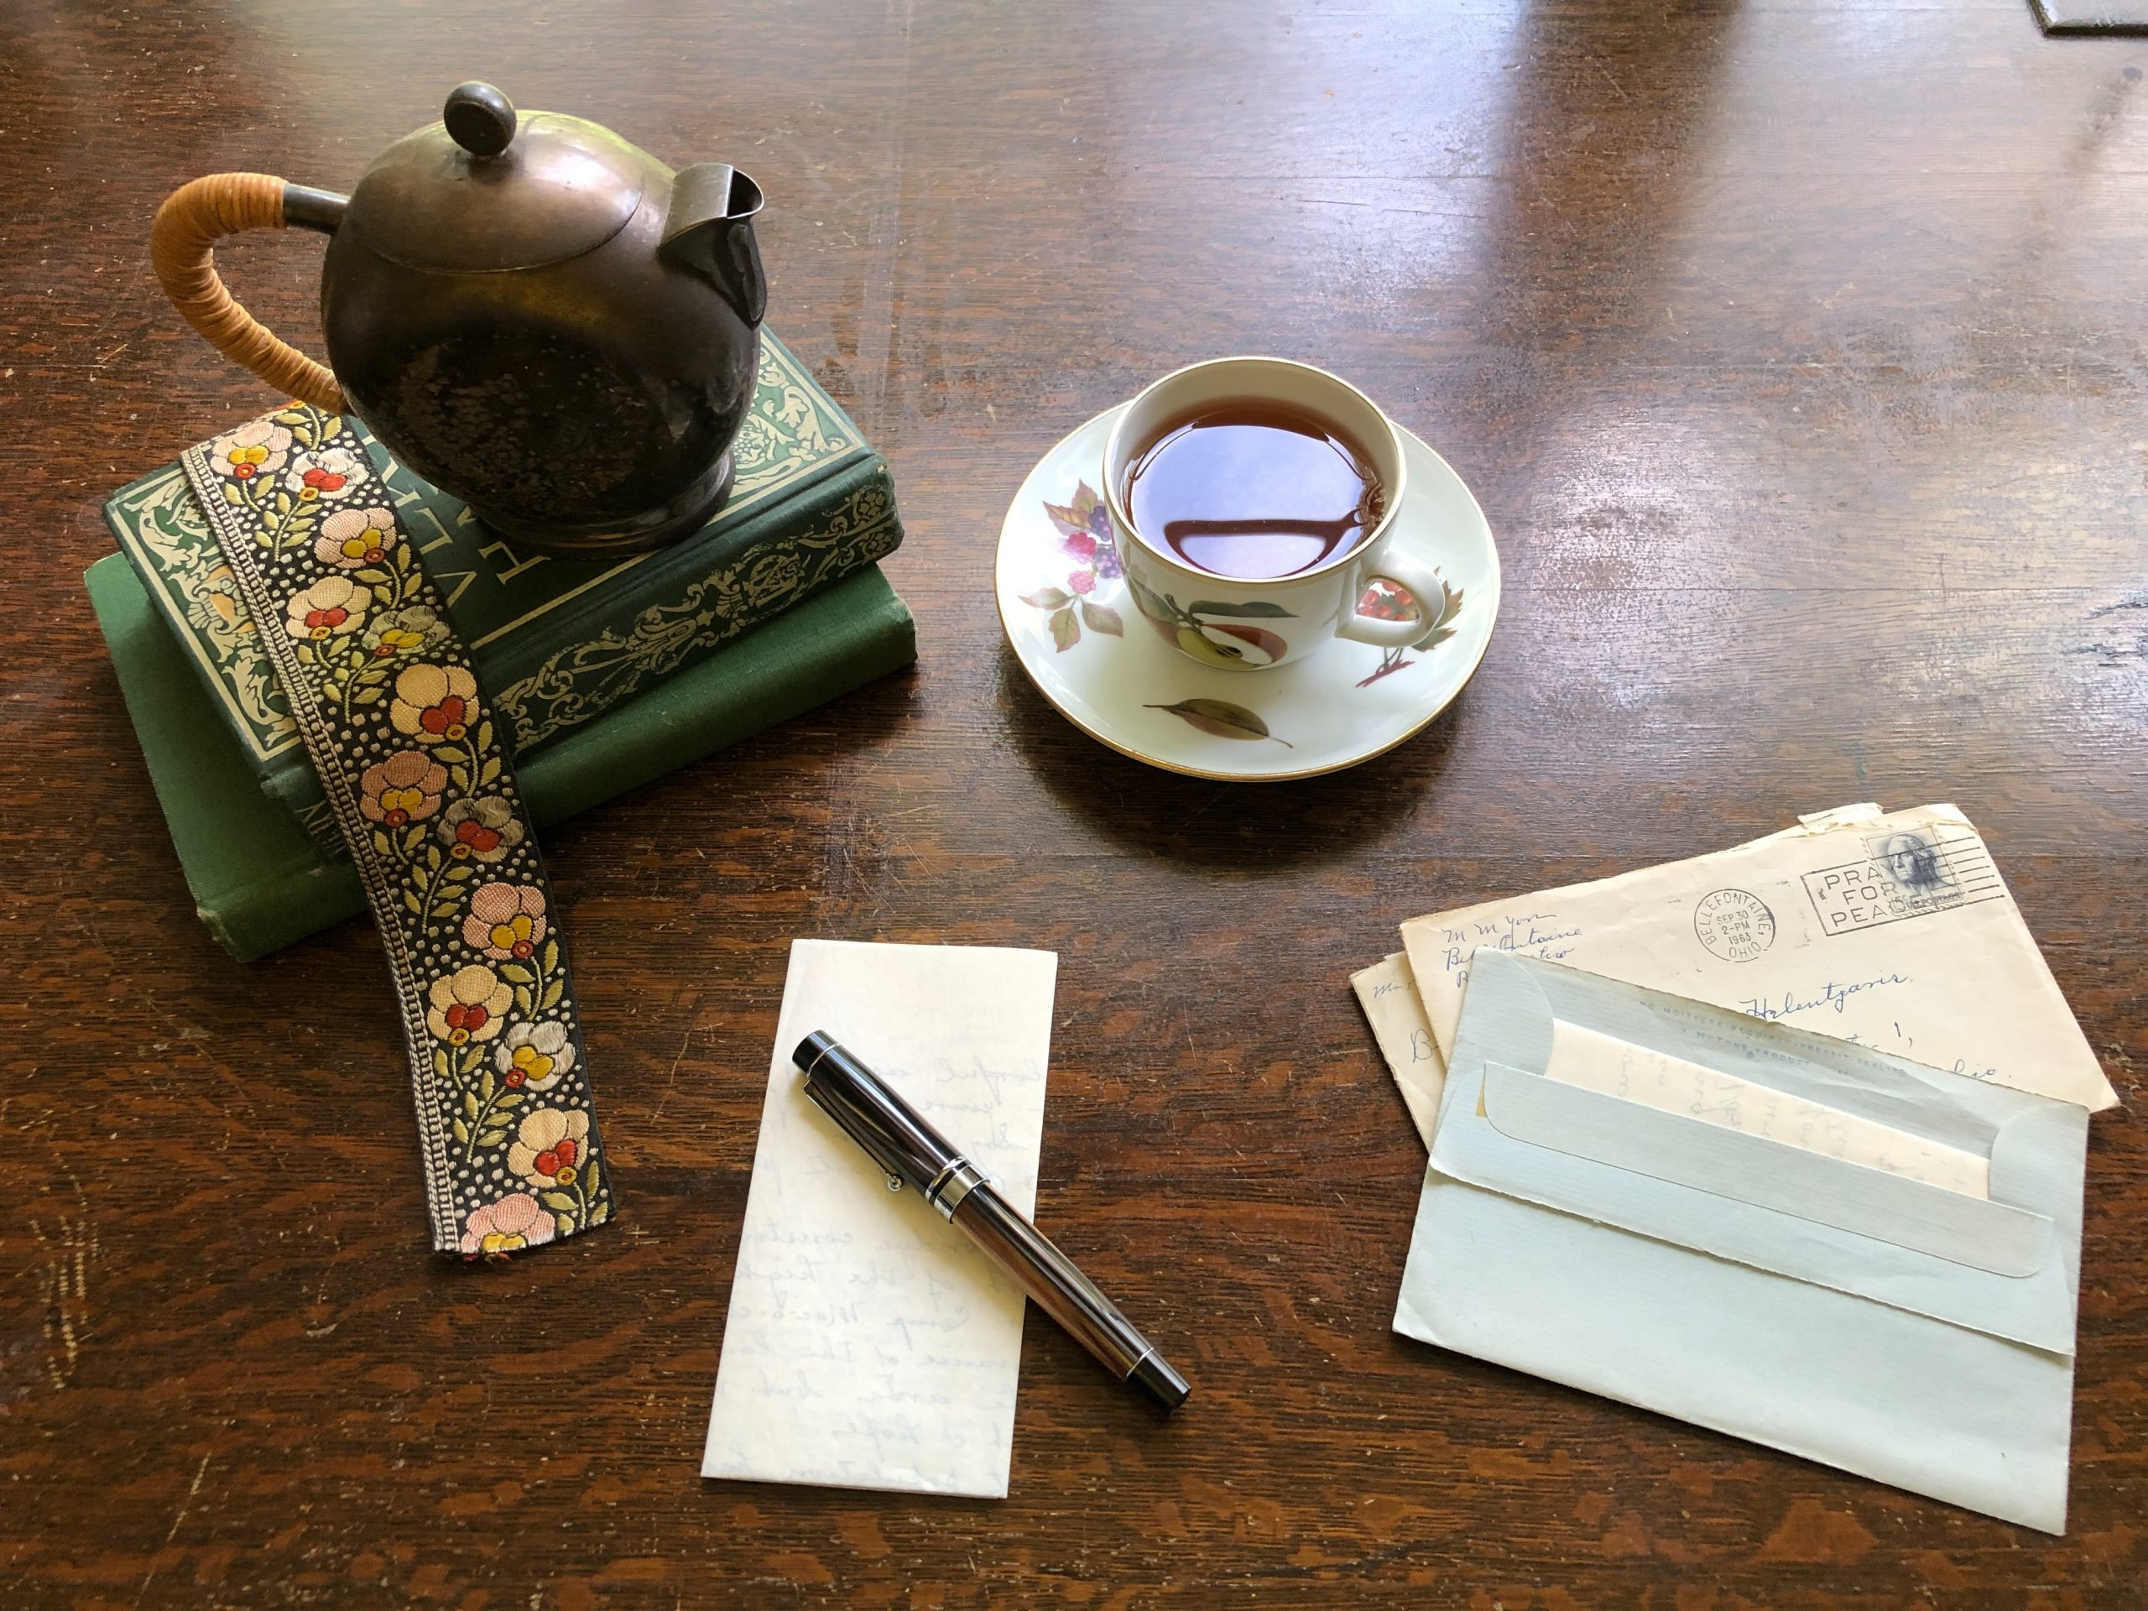

Photo by
on
Welcome to ENGL 087. In our class, we will explore writing as a way to express yourself, to convey your ideas to others, to demonstrate what you know, and to advance scholarship in your academic field. Most importantly, we will explore the ways that strong writing can help you to communicate your unique thoughts and opinions.
You already have good writing skills in your first language(s). To enter scholarly conversations in the U.S., the next step is to sharpen your academic writing skills in American English. This text aims to help you uncover the expectations of professors and scholars in the U.S. regarding writing and critical thinking, to help you succeed in college.
We invite you to be open to new ways of thinking about writing. Together, we will examine ways to use writing to discover what we think and believe. We will use writing to find our voice and power, and to create change in the world around us.
Good writing is both an art and a science. The best way to learn both aspects is to practice. The more you write, the better you will be at writing. Often, the key to full participation in academic work is writing – this is the way scholars communicate. Through our class, we want to make sure that you can communicate your ideas clearly. We know that this takes hard work and dedication on your part, and we applaud your choice to embark on this journey.



Photo by
on

Writing to Create Change

“…change is the only constant in life….”
~ attributed to Heraclitus (c. 500BCE)

Photo by
on
Here in this part of North America (in Maryland we are in the mid-Atlantic region), we enjoy four seasons, so the deciduoustrees and the landscape are always changing around us. Similarly, everything around us – including ourselves – undergoes change constantly as the Earth rotates and revolves.

Activity A ~ Proverbs about Change
Do you know any sayings or proverbs about change? Search your memory for sayings in your own language and in English. Brainstorm ideas with your partner, then write your proverbs on the board in the original language and explain them to the class.
U.S. President John F. Kennedy said this about change, and the danger of staying too much in the past:
“And our liberty, too, is endangered if we pause for the passing moment, if we rest on our achievements, if we resist the pace of progress. For time and the world do not stand still. Change is the law of life. And those who look only to the past or the present are certain to miss the future.”
~ “Address in the Assembly Hall at the Paulskirche in Frankfurt (266),” June 25, 1963, Public Papers of the Presidents: John F. Kennedy, 1963.
Good writing is a powerful tool to effect change. In our class, we will write about ways to create change to improve our communities. What are your big (or small) ideas about change?

Activity B ~ Change in Your Community
Discuss these questions with a partner:
1. What communities do you belong to?
2. What could be better about your communities? What changes would you suggest?
3. Brainstorm a list of challenges or problems that you see in your community and the world. Think of things that you would like to see changed. For now, don’t worry about how you would create the change; just brainstorm ideas. No idea is too big or too small to add to your list.
If you get stuck, open these documents for inspiration:
United Nations Sustainable Development Goals (opens in new tab)
United Nations Sustainable Development Topics (opens in new tab)
In our class, we will write to create change. Throughout the semester, we will talk about your ideas to make the world a better place. Keep a list of your ideas so that you are ready to write an essay later in the semester.
JFK quote retrieved from the
website.

PART I

Before You Write
In this section, we will discuss things to consider before you start to write, as well as how to start writing for academic purposes.

Photo by
on

Activity A ~ Brainstorming about Writing & Noticing Writing in Your Daily Life
- On your own: On a piece of paper, write down all the types of writing you have done in the past week (grocery lists, social media messages, homework, etc.). Be specific.
- With a partner: What kinds of writing do you need to do in college? Is all of the writing graded? What kinds of assignments or exams require writing? Make another list with your partner.
- With your class: What was the purpose of your writing? Who was your audience?
This week, pay attention to the types of writing that you do and see in your daily life.
Start today by noticing the kinds of texts you see and hear around you every day: street signs, signs and posters at the college, news articles, podcasts, etc. How does that kind of writing affect the world?
Take a photo of writing that you notice in the community around you.
In college, you will have many opportunities to write: lab reports, business proposals, timed short-answer responses and essays, annotated bibliographies, term papers, and so on. Each of these types of writing has its particular audience, purpose, and context. In many cases, you will be writing to discover more about what you believe, or to show what you have learned.
In ENGL 087, we will also be writing to effect change. Over the next few weeks, think about the activity below; later in the semester, you will write more about your ideas for change.

Activity B ~ Change in Your Community
What communities do you belong to? Describe them to a partner.
In your communities this week, notice things that could be improved. What changes would you suggest?
In our class, we will write to create change. Throughout the semester, we will talk about your ideas to make the world a better place. Keep a list of your ideas so that you are ready to write an essay later in the semester.
Activity adapted from from
p. 38 Activity 2.1 An introduction to the purposes of writing.

Chapter 1

Audience, Purpose, & Context

Questions to Ponder
Discuss these following scenario with your partners:
Imagine you are a computer scientist, and you have written an important paper about cybersecurity. You have been invited to speak at a conference to explain your ideas. As you prepare your slides and notes for your speech, you are thinking about these questions:
- What kind of language should I use?
- What information should I include on my slides?
Now, imagine you are the same computer scientist, and you have a nephew in 3rd grade. Your nephew’s teacher has invited you to come to his class for Parents’ Day, to explain what you do at work. Will you give the same speech to the class of eight-year-olds? How will your language and information be the same or different?

Thinking about audience, purpose, and context
Before we give the presentations in the scenarios described above, we need to consider our audience, purpose, and context. We need to adjust the formality and complexity of our language, depending on what our audience already knows. In the context of a professional conference, we can assume that our audience knows the technical language of our subject. In a third grade classroom, on the other hand, we would use less complex language. For the professional conference, we could include complicated information on our slides, but that probably wouldn’t be effective for children. Our purpose will also affect how we make our presentation; we want to inform our listeners about cybersecurity, but we may need to entertain an audience of third graders a bit more than our professional colleagues.
The same thing is true with writing. For example, when we are writing for an academic audience of classmates and instructors, we use more formal, complex language than when we are writing for an audience of children. In all cases, we need to consider what our audience already knows, what they might think about our topic, and how they will respond to our ideas.
In writing, we also need to think about appearance, just as we do when giving a presentation. The way our essay looks is an important part of establishing our credibility as authors, in the same way that our appearance matters in a professional setting. Careful use of MLA format and careful proofreading help our essays to appear professional; consult MLA Formatting Guides for advice.

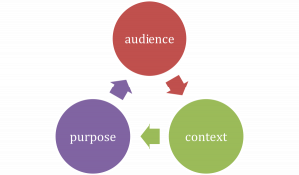

Before you start to write, you need to know:
Who is the intended audience? (Who are you writing this for?)
What is the purpose? (Why are you writing this?)
What is the context? (What is the situation, when is the time period, and where are your readers?)
We will examine each of these below.

AUDIENCE ~ Who are you writing for?
Your audience are the people who will read your writing, or listen to your presentation. In the examples above, the first audience were your professional colleagues; the second audience were your daughter and her classmates. Naturally, your presentation will not be the same to these two audiences.
Here are some questions you might think about as you’re deciding what to write about and how to shape your message:

    - What do I know about my audience? (What are their ages, interests, and biases? Do they have an opinion already? Are they interested in the topic? Why or why not?)
    - What do they know about my topic? (And, what does this audience not know about the topic? What do they need to know?)
    - What details might affect the way this audience thinks about my topic? (How will facts, statistics, personal stories, examples, definitions, or other types of evidence affect this audience?)
In academic writing, your readers will usually be your classmates and instructors. Sometimes, your instructor may ask you to write for a specific audience. This should be clear from the assignment prompt; if you are not sure, ask your instructor who the intended audience is.

PURPOSE – Why are you writing?
Your primary purpose for academic writing may be to inform, to persuade, or to entertain your audience. In the examples above, your primary purpose was to inform your listeners about cybersecurity.

Audience and purpose work together, as in these examples:
- I need to write a letter to my landlord explaining why my rent is late so she won’t be upset. (Audience = landlord; Purpose = explaining my situation and keeping my landlord happy)
- I want to write a proposal for my work team to persuade them to change our schedule. (Audience = work team; Purpose = persuading them to get the schedule changed)
- I have to write a research paper for my environmental science instructor comparing solar to wind power. (Audience = instructor; Purpose = informing by analyzing and showing that you understand these two power sources)
Here are some of the main kinds of informative and persuasive writing you will do in college:
INFORMATIVE WRITING | PERSUASIVE WRITING
describes | argues
explains | defends
tells a story | convinces
summarizes | justifies
analyzes | advocates
compares/contrasts | supports

How Do I Know What My Purpose Is?
Sometimes your instructor will give you a purpose, like in the example above about the environmental science research paper (to inform), but other times, in college and in life, your purpose will depend on what effect you want your writing to have on your audience. What is the goal of your writing? What do you hope for your audience to think, feel, or do after reading it? Here are a few possibilities:
- Persuade or inspire them to act or to think about an issue from your point of view.
- Challenge them or make them question their thinking or behavior.
- Argue for or against something they believe or do; change their minds or behavior.
- Inform or teach them about a topic they don’t know much about.
- Connect with them emotionally; help them feel understood.
There are many different types of writing in college: essays, lab reports, case studies, business proposals, and so on. Your audience and purpose may be different for each type of writing, and each discipline, or kind of class. This brings us to context.

CONTEXT ~ What is the situation?
When and where are you and your readers situated? What are your readers’ circumstances? What is happening around them? Answering these questions will help you figure out the context, which helps you decide what kind of writing fits the situation best. The context is the situation, setting, or environment; it is the place and time that you are writing for. In our examples above, the first context is a professional conference; the second context is a third-grade classroom. The kind of presentation you write would be very different for these different contexts.
Here’s another example: Imagine that your car breaks down on the way to class. You need to send a message to someone to help you.
AUDIENCE: your friends
PURPOSE: to ask for help
CONTEXT: you are standing by the side of Little Patuxent Parkway, 10 minutes before class begins. Your friends are already at the campus Starbucks or in Duncan Hall.
Do you and your readers have time for you to write a 1,000-word essay about how a car works, and how yours has broken down? Or would one word (‘help!’) and a photo be a better way to send your message?
Now imagine that you are enrolled in a mechanical engineering class, and your professor has asked for a 4-page explanation of how internal combustion works in your car. What kind of writing should you produce? This would be the appropriate audience, purpose, and context for the 1,000-word essay about how a car works.

Activity ~ A Note about Tone
As you consider your audience, purpose, and context, you will need to think about your word choice as well. For example, say these two phrases out loud:
- very sick kids
- seriously ill children
Do they mean the same thing? Would you use the phrases in the same way? How about:
- lots of stuff
- many items
The words we choose help determine the tone of our writing, which is connected to audience, purpose, and context. Can you think of other examples using formal and informal tone?

Is this chapter:
…about right, but you would like more detail? –> Watch “Audience: Introduction & Overview” and from Purdue’s Online Writing Lab. Also, view “Purpose, Audience, & Context” from The Ohio State University.
…about right, but you prefer to listen and learn? –> Try “Thinking About Your Assignment” from the Excelsior OWL and “A Smart Move: Responding the Rhetorical Situation.”
…too easy? –> Watch “Writing for Audiences in U.S. Academic Settings” from Purdue OWL.
Or, how about watching a funny video? In this short (3.5 minutes) video from the popular children’s program Sesame Street, Sir Ian McKellen tries to teach Cookie Monster a new word, but at first, Sir Ian doesn’t really understand what his audience knows (or doesn’t know), so Cookie Monster doesn’t understand.
Portions of this chapter were modified from the following Open Educational Resources:
Saylor Academy under a Creative Commons Attribution-NonCommercial-ShareAlike 3.0 License without attribution as requested by the work’s original creator or licensor.

“Audience” and “Purpose” chapters from The Word on College Reading and Writing by Carol Burnell, Jaime Wood, Monique Babin, Susan Pesznecker, and Nicole Rosevear, which is licensed under a Creative Commons Attribution-NonCommercial 4.0 International License, except where otherwise noted.

Note: links open in new tabs.

Chapter 2

Recursive Writing Process
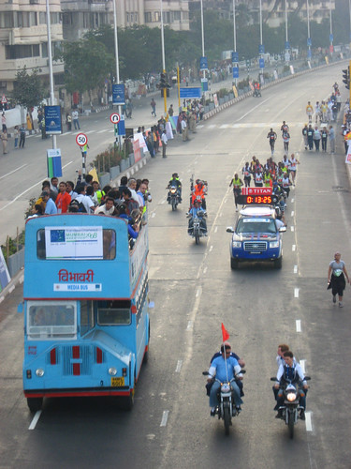



Good writing: It’s a Marathon, Not a Sprint!
Sometimes in college, your instructors will ask you to write several paragraphs, or even an essay, in a short period of time. Examples include short-answer exam questions and timed writing exercises. This kind of writing allows you to show that you have read and understood the assigned material, or that you have practiced writing in a particular style. You may only have enough time in the class period to write a quick first draft for these types of writing assignments. The purpose of this type of writing is to get your message across clearly and quickly.
However, many times, you will have longer essay assignments which require more reflection and analysis. These assignments will often require that you conduct research to find evidence to support your ideas, and you will be expected to do most of this work outside of class time. This type of assignment uses the recursive writing process. This means that you will follow several steps in your writing journey, pausing along the way to go back to a previous stage, then moving forward, then returning to the beginning, then moving forward again, and so on. Good writers regularly use these steps all the time; you will want to practice using them too. One key to success is to start your journey right away when you get an assignment; do not wait until the paper is almost due to begin your work, because then you will not have enough time to work through the writing process.

Activity ~ Finding Your Writing Process
Directions: Discuss with a small group: What is your writing process? How do you start working on a writing assignment?
Discuss the graphics below with your partners. Have you used any of these steps in the writing process? Which graphic do you like better? Can you draw one that works better for you?

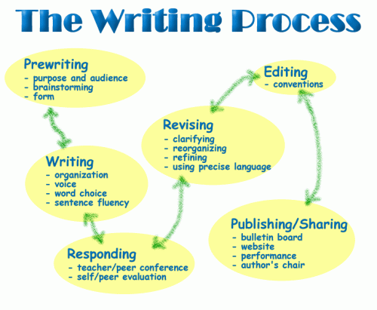

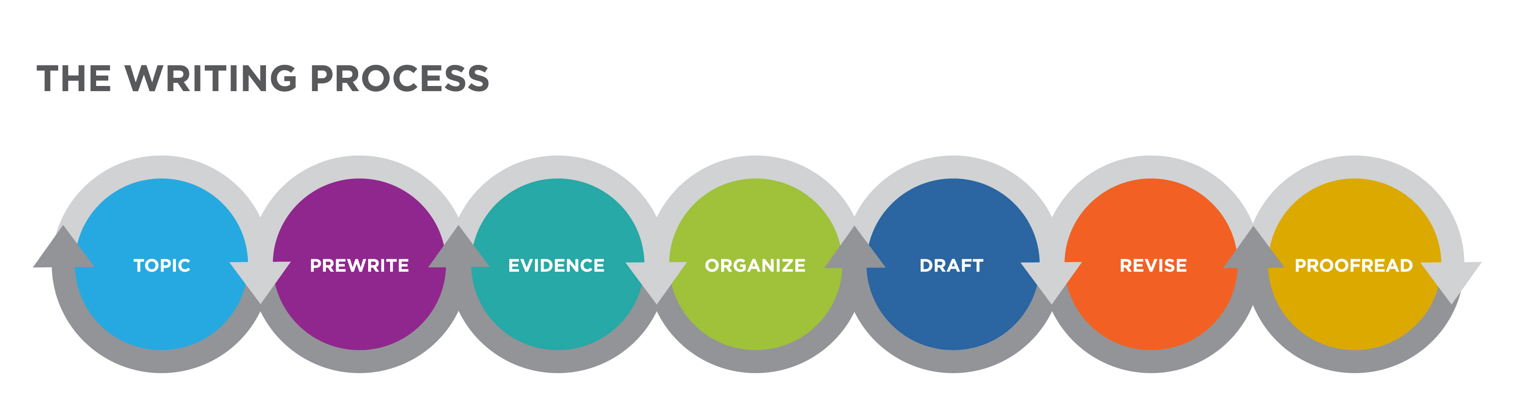

Good academic writing takes time. It’s a marathon, not a sprint, and there are many steps to writing well. One of the first steps is to make sure that you understand the writing assignment. Your instructor may give you a writing prompt with specific directions; ask for clarification if you do not understand something.
The next sections discuss basic information about some of the stages of the writing process. Remember to practice each of these with all of your writing assignments in our class.

Pre-writing: Why am I writing? What do I already know? What do I want my audience to know/learn?
Before you start drafting your essay, do some pre-writing. Brainstorm ideas, talk to a friend, complete a graphic organizer, draw pictures, freewrite, create an outline and a working thesis statement. At this stage, include all ideas that occur to you; do not edit anything out. You will probably want to return to your pre-writing ideas later in the process.
If you are writing a researched essay, this is the stage to start reading and researching about your topic. This means finding reliable sources and keeping track of them so that you can responsibly incorporate other scholars’ ideas into your own paper.

Drafting: What do I want to say? Where do I need more research?
Once you have some ideas, you can start drafting your essay. You can start with any section: Introduction, Body Paragraphs, or Conclusion. Or you can just start writing a paragraph, and decide later where it might fit. If you wrote an outline in the Pre-writing stage, now you can write paragraphs that fit into your outline.
Feeling stuck? Return to pre-writing. Look at the notes you created earlier in your first pre-writing phase. Is there anything there that you want to write a paragraph about? Is there anything there that you can expand on?
Try some more pre-writing; see if you can discover some more ideas, now that you have started drafting.
At this stage, it is useful to take a break. Put your essay aside for a day or two. After that, you may think of new ideas to incorporate.

Revising & Editing: Which areas need work?
When you revise, you ‘look again’ at your work. This is the time to edit your draft by deleting or changing words, sentences, and paragraphs that do not fit, or by moving them to a better place in your essay. This is also the time to add more information where you need more explanation or support. Return to your Pre-writing ideas, and do more brainstorming, freewriting, etc., if you need to expand some of your sections. Ask a writing partner or tutor to read your draft; it can be very useful to hear a reader’s reaction and advice at this point.
At this stage, remember to re-read the essay prompt. As you read your own essay, ask yourself: Does my essay answer the questions in the prompt? Is my thesis clear? Are all of my ideas connected to my thesis?
Consult this useful Revision Checklist from The Writing Center at the University of North Carolina at Chapel Hill (opens in a new tab).

Proofreading & Publishing: What mistakes can I fix?
One of the very last steps in the writing process is proofreading: checking for errors in grammar, mechanics, and formatting. When you are satisfied that you have done your best, you are ready to publish your work by handing it in to your instructor.
When you post an essay in Canvas, your instructor may allow you to use the plagiarism detection tool. This can help you to find areas where you have unintentionally copied from another source. If your instructor allows this step, be sure to leave yourself enough time to submit the essay and make any necessary adjustments.
Remember: good writing takes time. IT’S A MARATHON, NOT A SPRINT!

“
” from publicdomainvectors.org
…about right, but you would prefer to watch and listen? –> Try this video from Mometrix Academy on the “
” Or would you like to read more? –> Open this handout from MIT’s Writing & Communication Center: “
.”
“The Writing Process” (figure 1) has been released into the
(opens in a new tab) by its author, Luqa Primary. This applies worldwide. In some countries this may not be legally possible; if so: Luqa Primary grants anyone the right to use this work for any purpose, without any conditions, unless such conditions are required by law.
“Image of Writing Process” (figure 2). Authored by: Kim Louie for Basic Reading & Writingfor Lumen Learning. License: CC BY: Attribution
: links open in new tabs.

Chapter 3

Strategies for Getting Started

Carol Burnell, Jaime Wood, Monique Babin, Susan Pesznecker, and Nicole Rosevear
How do you start writing a draft? There isn’t just one right way to begin writing. Some people dive right in, writing in complete sentences and paragraphs, while others start with some form of brainstorming or freewriting. Others choose a strategy based on the writing task and how familiar they are with the topic. A writing instructor may want you to try out different methods so that you can figure out what works best for you. You may want to have more than one method in case you get stuck and need to break out of a writing block. Here are some common strategies for getting started (sometimes called invention strategies).
There are several methods that help you generate ideas and see connections between ideas without writing in complete sentences. We can call these methods “brainstorming.” They all have some common rules:
- Write down all of your ideas; don’t eliminate anything until you are done brainstorming.
- Don’t bother with editing at this stage.
- Work as quickly as you can.
- If you get stuck, stop and review your work OR get someone else’s input.
- Each method can work as a solo technique or with others.

Clustering
A cluster is a method of brainstorming that allows you to draw connections between ideas. This technique is also called a tree diagram, a map, a spider diagram, and probably many other terms.
- To make a cluster, start with a big concept. Write this in the center of a page or screen and circle it.
- Think of ideas that connect to the big concept. Write these around the big concept and draw connecting lines to the big concept.
- As you think of ideas that relate to any of the others, create more connections by writing those ideas around the one idea that connects them and draw connecting lines.
Here’s an example:

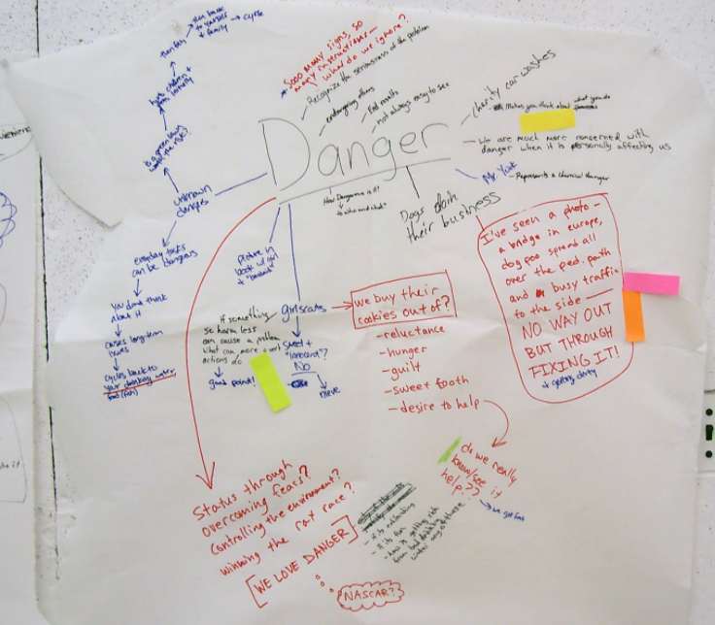

Notice that you can use color, larger type, etc., to create organization and emphasis. Remember that your cluster doesn’t need to look like anyone else’s. Create the cluster in the way that makes the most sense to you. Once you have finished the cluster, you can use another technique to generate actual text.

Listing
Listing is just what it sounds like: making a list of ideas. Here are two kinds of lists you might use.
Brainstorm list: Simply make a list of all the ideas related to your topic. Do not censor your ideas; write everything down, knowing you can cross some off later.
Here’s an example:
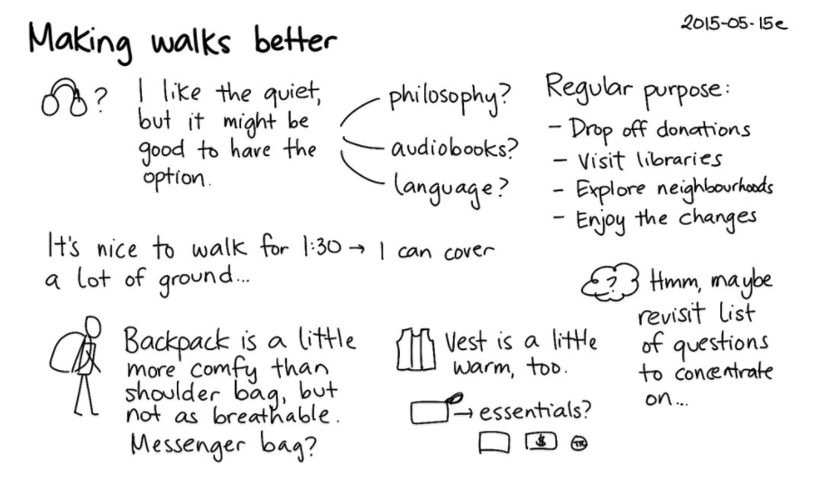
What I know/don’t know lists: If you know that your topic will require research, you can make two lists. The first will be a list of what you already know about your topic; the second will be a list of what you don’t know and will have to research.

Outlining
Outlining is a useful pre-writing tool when you know your topic well or at least know the areas you want to explore. An outline can be written before you begin to write, and it can range from formal to informal. However, many writers work best from a list of ideas or from freewriting. A reverse outline can be useful once you have written a draft, during the revision process.

Traditional Outline
A traditional outline uses a numbering and indentation scheme to help organize your thoughts. Generally, you begin with your main point, perhaps stated as a thesis, and place the subtopics, usually the main supports for your thesis/main point, and finally flesh out the details underneath each subtopic. Each subtopic is numbered and has the same level of indentation. Details under each subtopic are given a different style of number or letter and are indented further to the right. It’s expected that each subtopic will merit at least two details. NOTE: Most word-processing applications include outlining capabilities.
Phrase: Some outlines use a phrase for each item.
Sentence: Some outlines, particularly for oral presentations, use a complete sentence for each item.
Paragraph: Rarely, an outline may use a paragraph for each item.
Q&A: Some outlines are organized in a question/answer format.
Here’s an example:
I. Major Idea
a. Supporting Idea
i. Detail
ii. Detail
b. Supporting Idea
i. Detail
ii. Detail
iii. Detail

Rough Outline
A rough outline is less formal than a traditional outline. Working from a list, a brainstorm, or a freewrite, organize the ideas into the order that makes sense to you. You might try color-coding like items and then grouping the items with the same color together. Another method is to print your prewriting, then cut it up into smaller pieces, and finally put the pieces into piles of related items. Tape the like items together, then put the pieces together into a whole list/outline.
Ready to try an outline? Watch the YouTube video below, “Outlines” from the University of North Carolina at Chapel Hill, to help yourself get started.
https://youtu.be/aZUrlFY84Kw

Freewriting
Freewriting is a technique that actually generates text, some of which you may eventually use in your final draft. The rules are similar to brainstorming and clustering:
- Write as much as you can, as quickly as you can.
- Don’t edit or cross anything out. (Note: if you must edit as you go, just write the correction and keep moving along. Don’t go for the perfect word, just get the idea on the page.)
- Keep your pen, pencil, or fingers on the keyboard moving.
- You don’t need to stay on topic or write in any order. Feel free to follow tangents.
- If you get stuck, write a repeating phrase until your brain gets tired and gives you something else to write. (Variation: I like to complain at this point, so I write about the fact that I’m stuck, I really hate having to do this, why isn’t it lunch-time already, etc.)
- Freewriting can be used just to get your mind working so that you can write an actual draft. In this case, you can write about whatever you want. Freewriting to generate ideas usually works best when you start with a prompt–an idea or question that gets you started. An example of a writing prompt might be “What do I already know about this topic?” Or “What is the first idea I have about my topic?” If you started with a list or an outline, you can freewrite about each item.

Looping
Looping is a technique built on freewriting. It can help you move within a topic to get all related ideas into writing.
- To begin, start with a freewrite on a topic. Set a timer and write for 5-15 minutes (whatever you think will be enough time to get going but not so much that you will want to stop).
- When the time period ends, read over what you’ve written and circle anything that needs to be fleshed out or that branches into new ideas. Select one of these for your next loop.
- Freewrite again for the same time period, using the idea you selected from the first freewrite.
- Repeat until you feel you have covered the topic or you are out of time.

Asking Questions
To stimulate ideas, you can ask questions that help you generate content. Use some of the examples below or come up with your own.
Problem/Solution: What is the problem that your writing is trying to solve? Who or what is part of the problem? What solutions can you think of? How would each solution be accomplished?
Cause/Effect: What is the reason behind your topic? Why is it an issue? Conversely, what is the effect of your topic? Who will be affected by it?
The set of journalist’s questions is probably the most familiar for writers. Using the journalist’s questions, sometimes called the five W’s, is an effective way to write about the basic information about your topic. Here are the questions:
- Who: Who is involved? Who is affected?
- What: What is happening? What will happen? What should happen?
- Where: Where is it happening?
- When: When is it happening?
- Why/how: Why is this happening? How is it happening?
If you imagine the questions as a cube, and separate why and how into two, you can use that visual image to remember the six questions.

PART II

Academic Honesty
As members of an academic community, we all have a responsibility to act with integrity, which means, for example, behaving ethically and honestly inside and outside the classroom, during exams, and when we prepare homework and writing assignments. The rules of academic honesty, and what constitutes cheating and plagiarism, may be different in different countries. In the U.S., when your name is at the top of an class assignment, it means that you – and you alone – have created the work. Many instructors encourage collaboration and research on some assignments, so in this section, we will discuss how to acknowledge other people’s contributions to your work.
Before you begin this section, read HCC’s Academic Honesty Procedure 10.02.01 from the college website. Can you summarize the main points of the college’s position on academic honesty?

Note: After you read this section on Academic Honesty, you may still have questions about academic integrity. Our HCC librarians have created a resource to help you. You may want to bookmark this for future reference in your academic career:
(opens in new tab).

Chapter 4

Summarizing
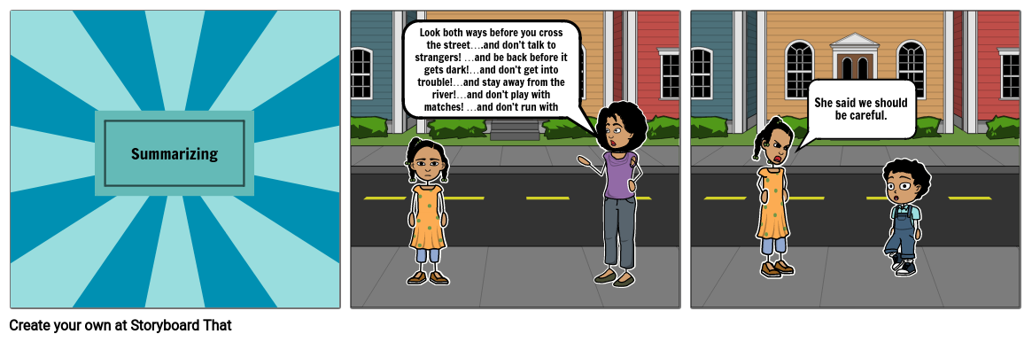
Summarizing well is an important skill for college conversations, presentations, and writing. It is a difficult skill that requires practice; you will get better each time you write a summary. Here are some tips to help you succeed.

Consider Your Audience & Purpose
Audience: someone (classmate, instructor, fellow researcher) who hasn’t read the original passage
Purpose of academic summary: to briefly tell the main ideas of an original passage in your own words. A good summary does two things:
- it shows that you thoroughly understand the original text, and
- it saves time for your readers, since they don’t need to read the entire original text to understand the main ideas

Close Reading
The first step to writing a strong summary is to thoroughly understand the original text. This means that you need to take your time, carefully reading, annotating, and re-reading the original text. Underline, highlight, and take notes on the main ideas while you read. This type of close reading will help you understand the text.
As you read the original passage, think about these “reporter questions” (also called “information questions”):
- who? what? when? where? why? how?
In other words, as you read, think about who is involved, what they are doing, when it is happening, and so on. The answers to these questions will guide you to the author’s main ideas.

Introductory Sentence
When you write an academic summary, you need to include attribution, often in your Introductory (first) Sentence. Attribution includes the following information from the work that you are summarizing, if it is available:
- title
- author (or speaker of a podcast, video, etc.)
- source (optional – advised especially if author is unknown)
Sometimes you may not know some of this information. (For instance, there is no author listed on HCC’s webpage about Academic Honesty.) In that case, just include as much as you know.
The beginning of a good summary also clearly shows the overall main idea, or thesis, of the reading passage. A strong Introductory Sentence should include:
- attribution (author or speaker, title of work, source if needed)
- thesis
Here are some suggested formats to incorporate the attribution and thesis in your summary. These are sample Introductory Sentences for a summary of the article “How Praise Became a Consolation Prize“:
- In “How Praise Became a Consolation Prize,” from The Atlantic, Christine Gross-Loh interviews Carol Dweck about the over-simplification of Dweck’s theories about growth mindset.
- “How Praise Became a Consolation Prize,” which appeared in The Atlantic, was written by Christine Gross-Loh to clarify misunderstandings in popular opinion about fixed vs. growth mindsets.
- Christine Gross-Loh, author of “How Praise Became a Consolation Prize,” in The Atlantic, argues that teachers’ misconceptions about growth mindset can cause them to create more harm than good.
Notice that we use the present tense here; we say “the author argues” or “the author explains” instead of “argued” or explained.” We also use strong verbs that accurately show the original author’s purpose and overall pattern of organization, such as analyzes, argues, claims, compares, defends, defines, describes, explains, relates, suggests, synthesizes, etc.

Main Ideas
After your Introductory Sentence, write the author’s main ideas in your own words. Be careful to include only the author’s ideas, and not your own. Here are some things not to include in your academic summary:
- small details – include only the main points
- your own opinion or reflection about the original passage
- other information that is not in the original passage, even if you know that it is true
When you write an academic summary, your job is to report on the author’s work in your own words, and to condense a longer passage.

Note on Summary-Response Essays
Summarizing is a very useful skill in many different types of essay. Generally, an academic summary includes only the original author’s main ideas, not your own opinion. In some courses, you will be asked to write summary-response essays. In these, you will summarize other authors’ work and then respond to that work with your own opinions and ideas.

Activity ~ Summarizing Practice
Summarizing is a difficult skill to learn, but it will become easier with practice. Here are some ways you can practice every day:
In real life….
- after you have a conversation with a friend, practice telling yourself the main points of the conversation in 1-2 sentences
- after you watch a movie or show, tell a friend the main storyline in 2-3 sentences
- listen to music with lyrics, then think of 1-2 sentences to summarize the song
In your academic life…
- every time you have to read for another class, read with a pencil in your hand. Practice the close reading technique: underline, highlight, take notes on the main ideas
- keep a notebook: practice summarizing the readings you do for your classes
- your ENGL 087 instructor may assign summarizing homework. Remember: regular practice will help you improve

Photo by
on

Chapter 5

Using Paraphrases & Quotations

Often, when you are writing a college essay, you will want to include other people’s ideas and research. This is a good way to enter the scholarly conversation about your topic, and to demonstrate your credibility as an author, because it shows that you have read and considered other experts’ ideas. Your audience will be able to see that you understand what has already been said about the topic, before you contribute your new ideas. In addition to summarizing (as discussed in a previous chapter), there are two other ways to incorporate other people’s ideas: by writing a paraphrase, or by using a direct quotation.
In general, paraphrasing means using your own words to express another person’s idea. When writers talk about using “a paraphrase,” they mean something a bit more specific: a paraphrase is a re-statement of another person’s idea, using your own words, and in about the same length as the original. Note that successful paraphrasing is not the same thing as “patchwriting,” which happens when you just change a couple of words or re-arrange a few words. You want to avoid patchwriting and use paraphrases instead, to preserve academic integrity and avoid plagiarism.
Quoting means using the exact words of another person in your work. When you use quotations, you must always use quotation marks (“….”) to show that these words belong to someone else. When you write a paraphrase or use a quotation, you must include citations to stay honest with your academic work. After we practice paraphrasing and quoting, we will work on citations in the next chapter.

Paraphrases & Quotations
In general, it is preferable to use paraphrases rather than long quotations in a short academic essay. Using a paraphrase demonstrates that you understand the original author’s ideas thoroughly; using quotations can make it seem like you are just “dropping in” a quote that seems related into your paper. Sometimes, however, a quotation is preferable, as when the original author captures an idea so perfectly that their exact words are an important part of the message. Other times, it may be that the original quotation is full of discipline-specific jargon, and needs to be quoted as is. The next two sections will discuss both strategies so that you can choose which is better for your audience, purpose, and context.

Using Paraphrases
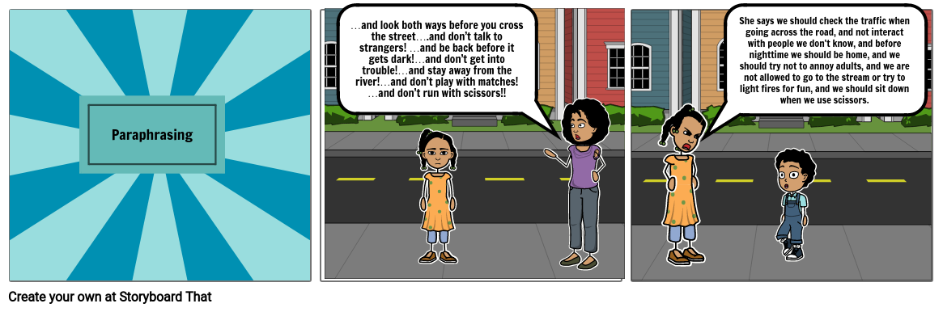

Paraphrasing well is very useful, but paraphrasing can be a difficult skill to master. It takes a great deal of practice to paraphrase academic material well, and even more practice to paraphrase well in a second language. You need to have excellent command of sentence structure and vocabulary in order to be an expert at paraphrasing. Working on this skill will help you to develop other language skills as well. The more you practice, the better you will be at paraphrasing. And remember: always include information about where you got the information you are paraphrasing in an in-text citation. That way, your readers can find the original author’s work to read, if they are interested in learning more.
Once you have found a piece of writing – perhaps a sentence or two – that you would like to paraphrase, what do you do? Allow yourself time to follow the steps below.

Steps for Paraphrasing Successfully
- Read and annotate the original piece. Take notes on the author’s main ideas in your own words.
- Put the original aside. Go for a walk, stretch, take a nap.
- Re-read the original piece and look at your notes. Did you miss any main ideas?
- Find a friend, or use your phone or computer to record yourself. Using your notes, talk about the author’s main ideas.
- Write a first draft of a paraphrase. Your paraphrase should be about the same length as the original. If you get stuck, try using the paraphrasing strategies below. Think of this as an English-to-English translation of the author’s ideas. Remember to include information about your source (title, author) so that you remember where you found the original work.
- Re-read the original piece, and your paraphrase. Did you miss any main ideas? Did you remember to indicate whose original ideas these are (the in-text citation)? Remember to include only the author’s ideas here; do not add your own opinion or analysis.
- Revise your paraphrase as necessary. Make sure it sounds like something YOU have written – not the original author.
In an essay, you will also need to connect your paraphrase to your own ideas, and explain why you are using the author’s ideas. Often, writers will start by paraphrasing another author’s work, and then writing a response to it to express their own opinions and ideas.
As you practice writing paraphrases, it might be helpful to use a bilingual dictionary, an English-to-English dictionary, a translator, and/or a thesaurus. Ask your instructors about their policies for using these resources.

Paraphrasing Strategies
- use synonyms (unique -> uncommon)
- use antonyms (unique -> not ordinary)
- change word forms (unique individual -> individual’s uniqueness)
- switch active voice to passive voice (They made mistakes. -> Mistakes were made.)
- switch passive voice to active voice (Lunch was served. -> They served lunch.)
- use different conjunctions (but -> however)
- change sentence structure (simple to compound, compound to complex, compound to two simple sentences, etc.)
Note: You will want to use these strategies in combination to achieve the most successful paraphrases.

Activity ~ Paraphrasing Practice
Here is a brief passage from Sarah Boxer’s article in The Atlantic, “An Artist for the Instagram Age”:
“The fact that some folks have managed to make the scene while others get left out in the cold is integral to the excitement of participatory art. The thrill is akin to exotic travel, or getting to see Hamilton. Because not everyone who wants the experience actually gets the experience, these works, even if their intentions and messages are democratic, tend to become exclusive affairs.”
Which of the following is an appropriate paraphrase of this passage? (Focus on the paraphrases, not the incomplete in-text citation.) Why is that one better? Why is the other one less useful as a paraphrase? Discuss with your partner.
- The truth that many people have been able to attend these events as others have been shut out of them is key to what makes this kind of art appealing. The excitement is similar to visiting foreign countries or attending a showing of a sold-out musical. Since some people who wish to attend can’t do so, these art forms, despite not necessarily wanting to, often end up denying access to many would-be attendees.
- Boxer notes that this kind of art only maintains its appeal as long as there are more people clamoring to view it than can possibly actually view it. This reliance on scarcity means these artists are ultimately relying on elitist principles to find their success and remain in demand.

Using Quotations

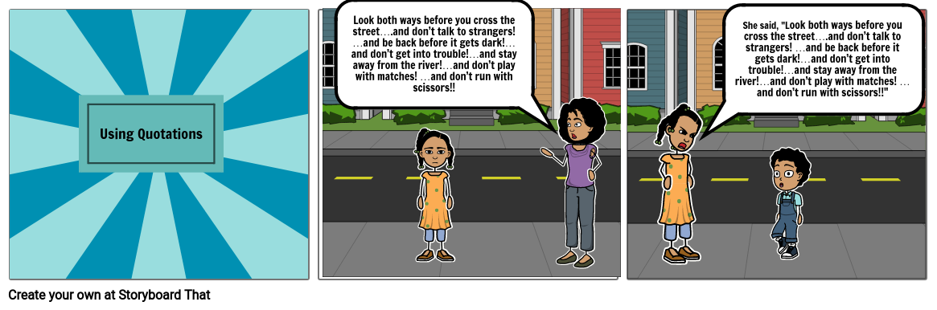
Quotations are useful when you feel like you just can’t say something better than the author did; they can be very powerful when you use them in the right situation. For instance, you may want to preserve the language of the time of the original, as in a historical document:
The opening lines of the U.S. Constitution read “We the People of the United States, in Order to form a more perfect Union,…”
or the rhythm and word choice of a speaker:
“I have a dream,” said Dr. Martin Luther King, “that one day….”
Or you may need to keep the original intact because it contains discipline-specific jargon that cannot be paraphrased successfully because the resulting paraphrase would be too long or unwieldy:
Computer scientists claim that “[u]sing a free Amazon Elastic Compute Cluster (EC2) t2.micro instance, [they] demonstrate that unCaptcha can solve reCaptcha’s audio challenges with 85.15% accuracy in 5.4 seconds, on average” (Bock et al. 2).
In these cases, directly quoting the original author or speaker may be the best choice. But be careful: you want to use quotations sparingly. If you use too many quotations, you will appear to be unsure about your own writing, or you will appear lazy. (It’s much easier to “drop” quotations in to an essay than to paraphrase and summarize the original author’s ideas.) Writing a paraphrase or summary shows that you really understand the author’s ideas, because you are explaining the ideas in your own words.
Note: When you use a summary, a paraphrase, or a direct quotation, you must always include attribution and make sure you have a matching entry for the source on your Works Cited page. See our chapter on In-text Citations & Works Cited Pages ~ MLA Format for more information.

For more advice and practice about using paraphrases, consult “
” from the University of Toronto University College’s Writing Centre, and “
” from Yale University’s Poorvu Center for Teaching and Learning.
For more on using quotations, see “
” from the University of Toronto University College’s Writing Centre.
Note: links open in new tabs.
Portions of this chapter were paraphrased from, and the Paraphrasing Practice Activity was from “Paraphrasing,” from The Word on College Reading and Writing by Carol Burnell, Jaime Wood, Monique Babin, Susan Pesznecker, and Nicole Rosevear, which is licensed under a Creative Commons Attribution-NonCommercial 4.0 International License, except where otherwise noted.

Note: links open in new tabs.
Works Cited
Bock, Kevin et al. “unCaptcha: A Low-Resource Defeat of reCaptcha’s Audio Challenge.” Usenix Workshop of Offensive Technologies (WOOT) 17. August 2017. Vancouver, BC. Conference Presentation.
King, Martin Luther, Jr. “I Have a Dream.” March on Washington for Jobs and Freedom. 28 August 1963. Washington, D.C. Speech.
United States Constitution. Preamble.

Chapter 6

In-text Citations & Works Cited Pages ~ MLA Format

Knowledge Preview
Try this quiz before you watch the video:

What Is a Citation? Why Do We Need Citations?
We give credit to other scholars by using citations in two places: in-text citations, and Works Cited pages. Watch the short video for some background information.
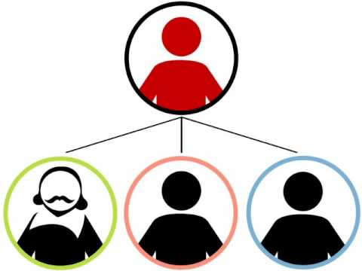
A YouTube element has been excluded from this version of the text. You can view it online here: https://pressbooks.howardcc.edu/engl087/?p=36

Note: Since I did not create this video, I need to include a citation here. In textbooks, you may find the citation for imported material directly under the material, and/or at the end of the chapter or book. In this textbook, you can find examples of both. Here is the citation for this video (not in MLA format):
A (Very) Brief Introduction. Authored by: libnscu. Provided by: NC State University. Located at: https://youtu.be/IMhMuVvXCVw. License: CC BY-NC-SA: Attribution-NonCommercial-ShareAlike
Any time we use another person’s ideas, spoken or written words, research, or other material, we must provide citations. This ensures that we maintain our academic honesty, and that we bring other scholars in to our written conversation by acknowledging their ideas.
We do not need to provide citations for common knowledge such as well-known scientific facts, historical events, or proverbs.

What Do We Need to Cite?
For all academic writing, we must be careful to give attribution for other people’s work, or for any information that is not common knowledge. This means two things:
- including information about the source directly in the text we have written (in-text citations), and
- including a list of materials used at the end of the essay (a Works Cited page)
Your in-text citations must always have a matching entry on your Works Cited page. That way, your readers can find more information about your source, so they can investigate more about your sources’ ideas on their own.

MLA (Modern Language Association) Format
academic disciplines.

MLA In-Text Citations

In your paper, when you quote directly from a source in its words, or when you paraphrase someone else’s idea, you need to tell the reader what that source is so the author gets credit. When you do this in the text of your paper, this is called an in-text citation.
In-Text citations are placed in parentheses, and have two components
- The first word found in the full citation on the Works Cited page (usually the last name of the author)
- The location of the direct quote or paraphrase (usually a page number)
In-Text citations should be placed directly after the direct quote or paraphrase, or in a place that is a natural pause and does not cause the reader to become distracted while reading the body of your work.
Example:

When using the author’s name in the sentence, only include the page number in the parentheses.
Example:
As Carol Dweck asserts, “The fixed mindset makes you concerned with how you’ll be judged; the growth mindset makes you concerned with improving” (13).
Your in-text citations would then need to have corresponding entries in your Works Cited page (see below).
How can we be sure if we need a citation? Use this graphic to help you decide:
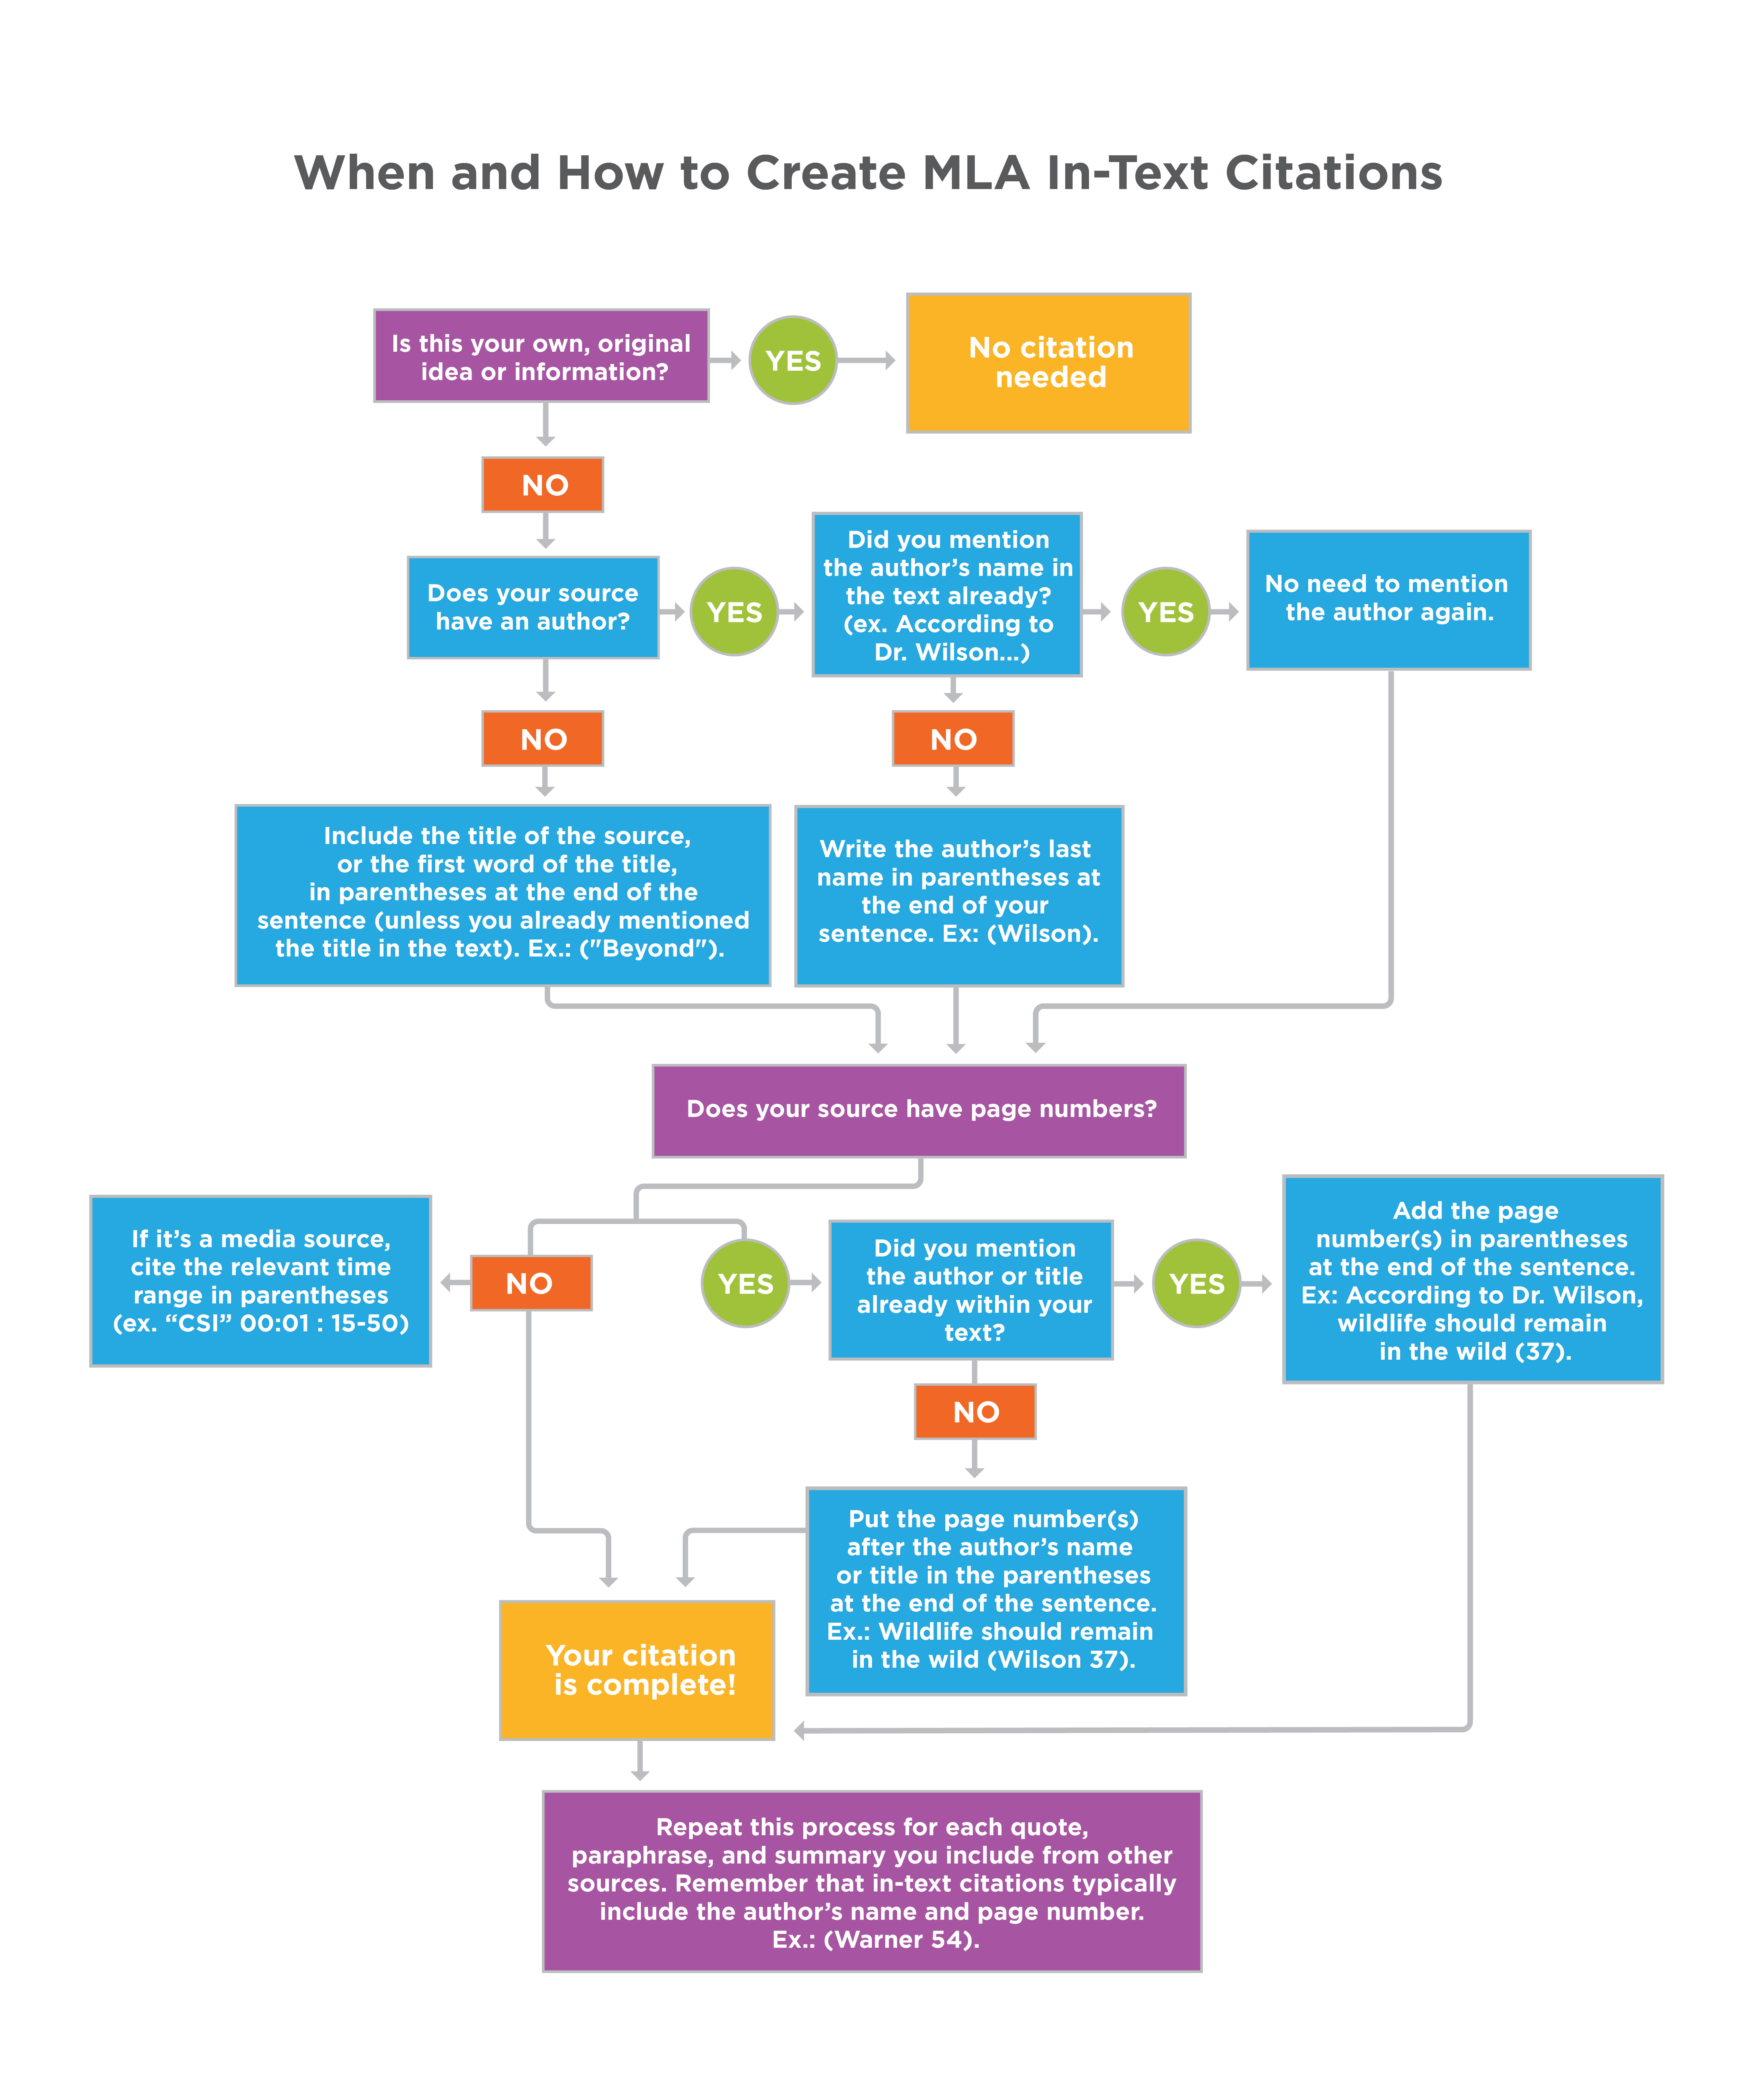
When and How to Create MLA Citations graphic. Authored by: Kim Louie for Lumen Learning. License: CC BY: Attribution

Integrating Sources

A. Two-minute Activity – Reporting Verbs
Work in groups of three.
Partner A: leave the room for 30 seconds
Partner B: tell Partner C about your favorite vacation spot. Give details.
Partner C: listen to Partner B and take notes
Next, Partner A returns to the room
Partner A & Partner B: listen to Partner C
Partner C: tell Partner A what Partner B just said
How does Partner C start the conversation? What ‘reporting verbs’ can Partner C use here? Did they use a paraphrase or a direct quotation?
Finally, brainstorm a list together of possible reporting verbs to use.
If time allows, switch roles with your partners, and choose a new topic from this list:
- your favorite restaurant
- someone you admire
- your favorite superhero
- top three bucket list items
- favorite movie
- least favorite food you’ve eaten
- your perfect day
- person you’d swap lives with for a day
- your spirit animal
To avoid ‘choppy’ writing, or writing that sounds like you just ‘dropped in’ a quote or paraphrase from another source, you will want to integrate other scholars’ ideas seamlessly into your own writing. Reporting verbs help to signal your reader that you are incorporating other scholars’ ideas. Notice that we use the present tense for these reporting verbs:
As Carol Dweck
, “The fixed mindset makes you concerned with how you’ll be judged; the growth mindset makes you concerned with improving” (13).
Check this list of MLA Signal Phrases from author Robin Jeffrey for more examples of reporting verbs. In your notebook, write some reporting verbs that are comfortable for you (ones you’ve used before) and some that are new for you (ones you’d like to try).

Works Cited Pages
A Works Cited page in MLA format is an alphabetical listing of all of the sources you have paraphrased, quoted, summarized, or reproduced (as in, for example, a photo or graph) in your essay; in other words, any source that you created an in-text citation for. Your Works Cited page will have an entry for each resource you used so that your readers can find the original source, in case they want to learn more from that expert. Each entry will include this information (if available): the author, title of source, title of container, other contributors, the version, number, publisher, date of publication, and location (page numbers, a DOI, or a URL, for instance). Check the links near the bottom of this page for more information and formatting guides.
As you conduct your research, it is helpful to keep a list of Works Consulted. As you write your essay, move the sources that have in-text citations to your Works Cited page. Then, when you are finished writing, attach your Works Cited page (the final, separate sheet of paper) to your essay.

Sample Works Cited entries:
North, Emily J, and Rolf U Halden. “Plastics and environmental health: the road ahead.” Reviews on environmental health vol. 28,1 (2013): 1-8. doi:10.1515/reveh-2012-0030
Dweck, Carol S. Mindset: the New Psychology of Success. Ballantine, 2016.
There are specific guidelines to follow for every kind of source (websites, blogs, videos, books, scholarly journals, etc.). The “Works Cited: A Quick Guide” from the MLA Style Center has the most recent advice on formatting your Works Cited pages.
Also, there are several citation generators available on the internet. Check with your instructors to find out about their policies regarding the use of citation generators.

B. Practice Activity
Try this practice activity.

Is this chapter
…too easy, or you would like a more comprehensive guide? –> Check this page on MLA In-Text Citations: The Basics, MLA Works Cited Page Basic Format, and the MLA Sample Works Cited Page, all from Purdue OWL.
…about right, but you would like to see more samples? –> Check “Building Credibility through Source Integration” from Lumen Learning’s Writing Skills Lab, and “Creating a Works Cited Page” and “Crediting and Citing Your Sources” from The Word on College Reading and Writing.
…too difficult, or you’d like more examples? –> Watch this video on “In-Text Citations for Beginners” for help. See also Lumen’s MLA Works Cited page for formatting help.
Portions of this chapter were adapted from “MLA In-Text Citations” from Developmental English: Introduction to College Composition. Provided by: Lumen Learning. License: CC BY-NC-SA: Attribution-NonCommercial-ShareAlike.and “MLA Documentation” from Basic Reading and Writing. Provided by: Lumen Learning. License: CC BY-NC-SA: Attribution-NonCommercial-ShareAlike.

The final practice activity is from “Practice: Using Sources” from Writing Skills Lab. Provided by: Lumen Learning. License: CC BY-NC-SA: Attribution-NonCommercial-ShareAlike.

Note: links open in new tabs.

Chapter 7

Avoiding Plagiarism

Knowledge Preview
Try this quiz before you read this chapter:

Plagiarism: What It Is and How to Avoid It
(see shaded box at end of chapter for Open Educational Resource attribution for this section)

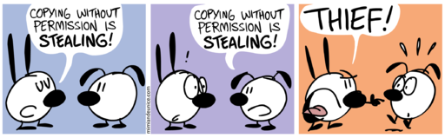

“
” by Nina Paley is available from Wikimedia Commons, under the
.

Plagiarism happens when we use another person’s intellectual materials and don’t give them credit. Intellectual property is defined as any kind of material (writing, art, music, film, etc.) or ideas envisioned and created by another person. Plagiarism can happen intentionally or unintentionally; authors have final responsibility for handing in their own work and carefully ensuring that they give credit for others’ work.
Plagiarism is a kind of academic dishonesty—a kind of theft. Colleges and universities take plagiarism seriously; many discipline or even expel students who are found to be plagiarizing.
How can you avoid plagiarism? Follow these steps:
- As much as possible, do your own work. In other words, always start by writing what you know about a subject. Handle outside sources respectfully; be sure to paraphrase, summarize, and use quotations properly.
- Start your research early, and take notes carefully. Don’t wait until just before your essay is due to start your research. When you add source material to your work, mark it so that you will remember it’s from a source. Cite the work immediately and add it to your works cited list.
- If you use someone else’s intellectual property, you must give them credit. If you bring their work into your assignment, you must mention them as the work’s owners. Remember: this includes all kinds of property: words, photographs, drawings, charts, graphs, poems, music, videos, etc. – and ideas that belong to someone else.
To give credit for intellectual property (also called source materials) in your academic writing, you must do the following:
- Create an in-text citation: Mention the source’s owner/creator in your written work at the point where the source is used.
- Create a list of all of the sources you used in your assignment; you’ll do this by arranging them in a Works Cited list at the end of your essay.
- Make sure sources on the Works Cited page are actually cited in your essay. If you read some source materials to learn more about your topic but do not mention them in your paper, you do not need to list them in the works cited list when using MLA format. But if you later end up using those sources in your paper, then you’ll need to add them to your works cited, so be sure to keep a list in your notebook of all of your sources. One strategy is to keep two lists:
  - Works Cited, and
  - Works Consulted – then, if you do later cite something from one of these sources, you can move it to the Works Cited list. You do not need to add your Works Consulted list to your final draft in MLA format.

Activity ~ Academic Honesty Scenarios
- Last semester, you started ENGL-087, but had to drop the class midway through the semester for personal reasons. This semester, to save time, you plan to submit the same first essay.
- Your homework assignment is to brainstorm ideas for an essay. You and your friend talk about some ideas, then you both write down your ideas and hand them in.
- Your friend asks you to study grammar together over the weekend.
- When you are doing some research online, you find some relevant, interesting information for your essay. You forget to write down the source, but you include the information in your draft.
- As you research your essay topic, you take notes from your sources. When you write your draft, you cannot think of a better way to say the information – the original author said it perfectly – so you copy and paste it from the original source into your essay.
- After you write your first draft of an essay, you go to the Composition & Literature Center (DH 210) for advice.
- Your best friend is taking a different section of ENGL-087. She tells you all about the grammar quiz from today’s class.
- One day in class, you are taking a test on Canvas. During the test, you sense that a classmate beside you is looking at your computer.
- You had to work late last night, so you didn’t have time to do the reading for today’s class. In your small group discussion, you sit quietly and take notes on what your partners say. Then you take the quiz on the reading.

Is this chapter:
…too easy, or you would like more information? –> Watch “Use Information Literacy,” a long video tutorial with quizzes created by our HCC librarians. The tutorial has helpful information about paraphrasing, summarizing, and using quotations. You can stop the tutorial at any time and re-start where you stopped later.
…about right, but you would like more information? –> Read “Defining Plagiarism” from the ENGL 099 text. Browse the pages before that as well for helpful information about academic integrity for all of your classes.
…about right, but you prefer to listen and learn? –> Watch “What is academic honesty?” from Northeastern Illinois University.
The “Plagiarism: What It Is and How to Avoid It” section of this chapter was adapted from “
” from
by Carol Burnell, Jaime Wood, Monique Babin, Susan Pesznecker, and Nicole Rosevear, which is licensed under a
, except where otherwise noted.

PART III

Writing Advice
In this section, we will examine how to write elegant sentences, paragraphs, and essays for academic audiences in the U.S.

Chapter 8

Unity & Coherence

Preserving Unity
Academic essays need unity, which means that all of the ideas in an essay need to relate to the thesis, and all of the ideas in a paragraph need to relate to the paragraph’s topic. It can be easy to get “off track” and start writing about an idea that is somewhat related to your main idea, but does not directly connect to your main point.

“
” by
is licensed under
All of the sentences in a paragraph should stay “on track;” that is, they should connect to the topic. One way to preserve unity in a paragraph is to start with a topic sentence that shows the main idea of the paragraph. Then, make sure each sentence in the paragraph relates to that main idea.
If you find a sentence that goes off track, perhaps you need to start a separate paragraph to write more about that different idea. Each paragraph should generally have only one main idea.
As you pre-write and draft an essay, try to pause occasionally. Go back to the assignment prompt and re-read it to make sure you are staying on topic. Use the prompt to guide your essay; make sure you are addressing all of the questions. Do not just re-state the words in the prompt. Instead, respond to the questions with your own ideas, in your own words, and make sure everything connects to the prompt and your thesis.

Activity A ~ Finding Breaks in Unity
Consider the following paragraphs. Is there a topic sentence? If so, do all of the other sentences relate to the topic sentence? Can you find any sentences that don’t relate?
*****
The planned community of Columbia, Maryland, was designed as a city open to all, regardless of race, level of income, or religion. When Columbia began in 1967, many cities in the U.S. did not allow people of certain races to rent or buy homes. Its developer, James W. Rouse, wanted to build a new city that had fair and open housing options for everyone. HCC has a building named for James W. Rouse. Today, the city’s nearly 100,000 remain diverse, as shown by recent census data.
*****
College can be expensive and difficult. Critical thinking is a very important skill for college students to develop so that they can be successful in their careers. Employers look for graduates who can understand information, analyze data, and solve problems. They also want employees who can think creatively and communicate their ideas clearly. College students need to practice these skills in all of their classes so that they can demonstrate their abilities to potential employers.
*****
Bananas are one of Americans’ favorite types of fruit. The Cavendish variety, grown in Central and South America, is the most commonly sold here in the U.S. Recent problems with a fungus called Panama disease (or TR4), however, have led to a shortage of Cavendish bananas. Similar problems occurred a few years ago in parts of Asia and the Middle East. Because the fungus kills the crop and contaminates the soil, scientists are concerned that the popular Cavendish banana could be completely eradicated. Bananas contain many nutrients, including potassium and Vitamin B6.
*****
Whether you choose to include a topic sentence or not, all of the sentences in your paragraph need to relate to the one main idea of the paragraph.
Another way to think about unity in a paragraph is to imagine your family tree. Draw a quick sketch of your family tree in your notebook. If you were writing an essay about your family, you might write a paragraph about close family members first. Next, you might branch out into another paragraph to write about more distant relatives. You might even include a paragraph about very close family friends, or pets. Each paragraph would have just one main idea (immediate family, more distant relatives, close family friends), and every sentence in each paragraph would relate to that main idea.

Activity B ~ Preserving Unity in Your Own Writing
Examine a composition that you have written for this class. Do all of your paragraphs have unity? Can you find any sentences that don’t relate to the topic of each paragraph? Exchange papers with a partner to peer review.

Ensuring Coherence
There are several ways to create connections between ideas in your essay. Here are some suggestions:
1. Repeat key words and phrases. This can be a powerful way to make a point. Consider this excerpt from Rev. Martin Luther King’s famous “I Have a Dream” speech at the 1963 March on Washington for Jobs and Freedom, in which he uses parallel structure:
I say to you today, my friends, so even though we face the difficulties of today and tomorrow, I still have a dream. It is a dream deeply rooted in the American dream.
I have a dream that one day this nation will rise up and live out the true meaning of its creed: “We hold these truths to be self-evident, that all men are created equal.”
I have a dream that one day on the red hills of Georgia, the sons of former slaves and the sons of former slave owners will be able to sit down together at the table of brotherhood.
I have a dream that one day even the state of Mississippi, a state sweltering with the heat of injustice, sweltering with the heat of oppression, will be transformed into an oasis of freedom and justice.
I have a dream that my four little children will one day live in a nation where they will not be judged by the color of their skin but by the content of their character. I have a dream today.
2. Use synonyms, as in this example, where King uses both repetition (“Let freedom ring”) and synonyms (for “mountains”):
And if America is to be a great nation, this must become true. So let freedom ring from the prodigious hilltops of New Hampshire. Let freedom ring from the mighty mountains of New York. Let freedom ring from the heightening Alleghenies of Pennsylvania. Let freedom ring from the snow-capped Rockies of Colorado. Let freedom ring from the curvaceous slopes of California. But not only that: Let freedom ring from Stone Mountain of Georgia. Let freedom ring from Lookout Mountain of Tennessee. Let freedom ring from every hill and molehill of Mississippi. From every mountainside, let freedom ring.
3. Use pronouns to refer to antecedents, as King does here; this can be more elegant than just repeating the key words and phrases:
I have a dream that my four little children will one day live in a nation where they will not be judged by the color of their skin but by the content of their character.
4. Use demonstratives (this, that, these, those) as adjectives or pronouns, as King does here:
I say to you today, my friends, so even though we face the difficulties of today and tomorrow, I still have a dream. It is a dream deeply rooted in the American dream.
I have a dream that one day this nation will rise up and live out the true meaning of its creed: “We hold these truths to be self-evident, that all men are created equal.”….
This is our hope. This is the faith that I go back to the South with. With this faith we will be able to hew out of the mountain of despair a stone of hope. With this faith we will be able to transform the jangling discords of our nation into a beautiful symphony of brotherhood.

Questions to Ponder
Pause for a moment here to think about the examples above. Think about audience, purpose, and context of an academic essay. Would you use the techniques for coherence in the same way that Dr. King did in his speech, or would you use the techniques in a different way? Discuss with a small group.

5. Use transitions. Transition words and phrases will help you to make sure your essay has coherence. Also called signal words/phrases or signposts, these help to guide your readers.
Transitions connect your related ideas; they can also show your reader that you are starting a new topic, giving an example, adding information, explaining causes and effects, and so on. Using the correct transition word or phrase in a sentence can make your writing much clearer. Try the activity below to think of possible transitions.

Activity C ~ Transition Words & Phrases
With your partner, brainstorm a list of transition words and phrases for each of the categories below.
compare/contrast | addition | cause/effect
example: similarly | also | because
Can you think of other transition words and phrases? What other categories do they belong to?
After you have completed these activities with your partner, consult Transition Words & Phrases ~ Useful Lists for more on compare/contrast, addition, cause/effect, and other transitions to try.

Activity D ~ Ensuring Coherence in Your Own Writing
Examine a composition that you have written for this class for coherence. Find and mark examples of places where you used repetition, synonyms, pronouns or demonstratives to build connections between ideas.
Underline your transition words and phrases. Did you use the strongest signal words? Can you find examples where you need to add a transition? Or, did you use too many transitions? Exchange papers with a partner to peer review.
Consult our chapter on Transitions for more inspiration on achieving coherence and cohesion in your writing. Challenge yourself to use some new transitions in your next composition.

Is this chapter:
…about right, but you would like more examples? –> Read “Cohesion and Coherence” from George Mason University’s Writing Center.
…too easy, or you would like more examples? –> Read “ESL: Coherence and Cohesion” from the Writing & Communication Center at the University of Washington/Bothell
Note: links open in new tabs.
Work Cited
King, Martin Luther, Jr. “I Have a Dream.” March on Washington for Jobs and Freedom. 28 August 1963. Washington, D.C. Speech.

Chapter 9

Paragraphs ~ Topic Sentences
Answer the questions in this quick quiz before you read the chapter:

An interactive or media element has been excluded from this version of the text. You can view it online here:
https://pressbooks.howardcc.edu/engl087/?p=44

by
on

What Is a Paragraph?
Let’s begin by defining the concept of the paragraph. A paragraph is a group of sentences that present, develop, and support a single idea. Some paragraphs are long; some paragraphs are short. There is no rule for exact length of paragraphs or number of sentences in a paragraph. One guideline is to have your paragraph take up two-thirds to three-fourths of a page, but paragraphs can be shorter or longer than that. In an essay, each new paragraph is indented; this helps your reader to see that you are shifting to a new topic.
In academic writing, we often combine paragraphs into a longer essay. The main idea of each paragraph supports the thesis of the essay.
Often, to help guide readers, the main idea of the paragraph is clearly expressed in a topic sentence.

Topic Sentences
The job of the topic sentence is to control the development and flow of the information contained in the paragraph. The topic sentence takes control of the more general topic of the paragraph and shapes it in the way that you choose to present it to your readers. Here is an example:
Additional state budget funding must be allocated to subsidize affordable housing initiatives.
What is the general topic here? What is the more focused, specific idea that the paragraph will address?
Additional state budget funding must be allocated to subsidize affordable housing initiatives.
The general topic (in bold type) is “affordable housing initiatives;” the more focused idea (in italics) is that “additional state budget funding must be allocated.”
Think about some places where you might commonly find general topics presented with more focus, perhaps in news stories, textbooks, or speeches. The topic of a news story might be a deadly forest fire that’s burning out of control, while the focus of the topic might be about careless humans. The topic of a chapter from a medical text might be phlebotomy (the practice of drawing blood from a patient), while the focus of a section of that chapter might be about safe disposal of used needles. Maybe the topic of a persuasive speech is organic produce, while the focus of the speech is about the importance of supporting local organic farms.
Most topics are big and broad, so they require more focus to provide a narrower view of the subject. Topic sentences provide focus in a paragraph; thesis statements provide focus in an essay. This narrower and more focused view also often tries to persuade the reader to see things from the writer’s perspective.
Note: The presentation of topics in an academic essay differs from the presentation of topics in a speech. Beginning speech writers often use obvious verbal signposts to announce main ideas, transitional moments, or concluding thoughts. On the other hand, academic writers use different kinds of signposts.
For example, in a speech for ENGL 085 or another class, you might say, “First, I will explain . . .” or “The first topic I will cover . . .” or “Next, I will tell you about . . .” or “In conclusion, as I have demonstrated . . . .” These methods for announcing a topic may be common and accepted practices in some college speech classes, but they do not suit the expectations of your audience for an academic essay. With an oral presentation, the audience can’t see how the speech will unfold, but with written text, readers can see the size and shape of the document that they’re reading, so they don’t need as much help navigating.
Here’s an example:
Speech-like announcement of a topic: First, I will explain that while it’s a common belief that use of cell phones causes lower levels of concentration and focus, cell phone use does have a place in the classroom and smart phones should be considered a valuable educational tool.
Essay-like presentation of a topic: While it’s a common belief that the use of cell phones causes lower levels of concentration and focus, cell phone use does have a place in the classroom, and smart phones should be considered a valuable educational tool.
Notice that this is a stronger position statement than this: “I think that cell phones are valuable.”
Tip: In a written college essay, try not to use transitions such as “In this essay, I will…,” “I believe that…,” or “In conclusion, my main idea is….” This is called “writing about writing,” and many professors feel that this weakens your writing. Instead, the preferred method is to state your idea or opinion directly. One way to do this in paragraphs is to use an explicit topic sentence.

Placement of Explicit Topic Sentences
A topic sentence can be at the beginning, in the middle, or at the end of a paragraph. Placing your topic sentence at or near the beginning of a paragraph is one good strategy. When you announce a topic clearly and early on in a paragraph, your readers are likely to understand your idea and to make the connections that you want them to make. This helps your readers relax because they don’t have to “hunt” for the main idea of the paragraph. However, it might be boring to structure every paragraph exactly the same way. For variety, you can also place topic sentences in the middle or at the end of your paragraph – it’s your choice as the author.

Details ~ Topic Sentence ~ Details
In Cinderella, a poor girl is forced by her cruel stepmother to clean, cook, and care for the home, while her evil, lazy stepsisters do nothing to help. In the version common in the U.S., Cinderella is always dressed in rags, and so cannot go to the prince’s celebration ball. The theme of a poor person conquering unfair oppression makes Cinderella a popular story in hundreds of countries. In most versions, Cinderella’s mean stepmother and stepsisters cruelly laugh at her, but kind, sweet Cinderella continues to do her work. Then, her fairy godmother appears and grants Cinderella her wish to attend the ball, by helping her dress in a beautiful gown and glass slippers. At the ball, Cinderella dances with the prince, who falls madly in love with her. Tension builds in the story, as Cinderella must leave before midnight, or her special clothes, shoes, and coach will disappear. As she hurries out of the palace, Cinderella loses one of her glass slippers, which eventually helps the prince to find her. They end up living happily ever after.
Details ~ Topic Sentence
In Cinderella, a poor girl is forced by her cruel stepmother to clean, cook, and care for the home, while her evil, lazy stepsisters do nothing to help. In the version common in the U.S., Cinderella is always dressed in rags, and so cannot go to the prince’s celebration ball. Her mean stepmother and stepsisters cruelly laugh at her, but kind, sweet Cinderella continues to do her work. Then, her fairy godmother appears and grants Cinderella her wish to attend the ball, by helping her dress in a beautiful gown and glass slippers. At the ball, Cinderella dances with the prince, who falls madly in love with her. Tension builds in the story, as Cinderella must leave before midnight, or her special clothes, shoes, and coach will disappear. As she hurries out of the palace, Cinderella loses one of her glass slippers, which eventually helps the prince to find her. They end up living happily ever after. The theme of a poor person conquering unfair oppression makes Cinderella a popular story in hundreds of languages.

Examples ~ Topic Sentence Placement
Consider some of the following examples of different topic sentence placements (beginning, middle, and end) in a paragraph from a description of the fairy tale Cinderella. The topic sentence is underlined in each example.
Topic Sentence ~ Details
The theme of a poor person conquering unfair oppression makes Cinderella a popular story in hundreds of countries. In Cinderella, a poor girl is forced by her cruel stepmother to clean, cook, and care for the home, while her evil, lazy stepsisters do nothing to help. In the version common in the U.S., Cinderella is always dressed in rags, and so cannot go to the prince’s celebration ball. Her mean stepmother and stepsisters cruelly laugh at her, but kind, sweet Cinderella continues to do her work. Then, her fairy godmother appears and grants Cinderella her wish to attend the ball, by helping her dress in a beautiful gown and glass slippers. At the ball, Cinderella dances with the prince, who falls madly in love with her. Tension builds in the story, as Cinderella must leave before midnight, or her special clothes, shoes, and coach will disappear. As she hurries out of the palace, Cinderella loses one of her glass slippers, which eventually helps the prince to find her. They end up living happily ever after.

: You may not need a topic sentence for every paragraph. Sometimes, you can group two or three related paragraphs together and write one topic sentence to introduce them all. Other times, you may choose not to make your topic sentence explicit. Our next section will elaborate on implicit topic sentences.

Implicit Topic Sentences
Sometimes, authors choose not to include an explicit topic sentence in every paragraph. Implicit topic sentences work especially well in narrative paragraphs or other kinds of creative writing. In stories, for example, you do not need to explicitly state the main idea of each paragraph. In long academic essays, we often have two or three closely-related paragraphs that need just one topic sentence to introduce them, so not every paragraph will have an explicit topic sentence.
There are also times when your main idea will be obvious enough without having to state your topic sentence directly. If you’re not sure about whether or not an implied topic is working in a paragraph, write an explicit topic sentence for the paragraph. Read the paragraph with and without your new explicit topic. Does addition of the explicit topic improve the clarity of the paragraph or essay? Share your writing with a some classmates or a writing tutor to get some second opinions. If you are not sure, ask your instructors about their preferences for your essays.

Characteristics of a Good Topic Sentence
A good topic sentence will:
- Announce the topic and the more focused ideas of the paragraph
- Present an idea or ideas that are clear and easy to understand
- Provide unity to the paragraph (so it’s clear how all supporting ideas relate)
- Omit supporting details
- Engage the reader
There’s no right order in the writing process for identifying or writing the topic sentence of a paragraph. Some writers begin drafting a paragraph with a main idea already in mind and then decide how to support it. Others begin writing about details, examples, or quotations from sources that they feel somehow relate to what they want to say, writing for a while before deciding what the main idea is. Most writers rely on a variety of strategies that they have developed through trial and error. So don’t let the lack of a main idea hold you back from getting out what you want to say. Pre-write and draft for a while, and a main idea will surely emerge.

Activity A ~ Finding Your Topic Sentences
Choose a composition you are working on, or have recently written, for our class. Ask your writing partner to find and underline your topic sentences. If your partner can’t identify a topic sentence in each paragraph, ask:
- Do I have an implicit topic sentence for that paragraph?
- If so, would an explicit topic sentence be better?
Do you agree with your writing partner? Revise your paragraphs as needed.

Activity B ~ Ensuring That Topic Sentences are Accurate
Choose another composition you are working on, or have recently written, for our class.
Provide a reader with a list of your topic sentences, without the paragraphs that they belong to. Ask the reader what he or she thinks each paragraph is about and what kind of supporting details or discussion he or she would expect to see in the paragraph.

Is this chapter on topic sentences:
…too difficult, or would you like a review? Read pp. 5-7, about topic sentences, in Introduction to Academic Writing for ESOL
…too easy, or you would like more challenge? Check this link for another explanation of topic sentences from the University of Toronto’s Writing Centre. Also see this page on Key Sentences from Lumen’s Writing Skills Lab.
…just right, but you would like more detail? Check this link for the original, unmodified text on “Writing Paragraphs” from The Word on College Reading and Writing from faculty at a community college in Oregon.
Portions of the above chapter were modified from “
” from
by Carol Burnell, Jaime Wood, Monique Babin, Susan Pesznecker, and Nicole Rosevear, which is licensed under a
, except where otherwise noted.

Chapter 10

Topic Sentences ~ More Examples

Here is more practice on Topic Sentences:

In academic writing, many paragraphs or groups of paragraphs start with topic sentences, which are like mini-thesis statements. Topic sentences are idea indicators, or “signs” that help guide a reader along from idea to idea.
Topic sentences have a topic and an angle, just like thesis sentences. But the angle of topic sentences usually is smaller in range than that of the thesis sentence. Very often the topic remains the same from thesis to topic sentence, while the angle shifts as the writer brings in various types of ideas and research to support the angle in the thesis.
Look at this sample again; these are topic sentences created from the thesis sentence. The topic remains the same in all (regular exercise) and the overall angle remains the same (benefits). But the angle narrows and shifts slightly from topic sentence to topic sentence as the writer brings in different supporting ideas and research.
Thesis Sentence | Topic | Angle
A regular exercise regime creates multiple benefits, both physical and emotional. | Regular exercise | Physical and emotional benefits
Topic Sentence | Topic | Angle
One physical benefit of having a regular exercise regime is longevity. Recent studies have shown that… | Regular exercise | Physical benefit of longevity
Exercise reduces heart and cholesterol rates when done at least three times per week… | Regular exercise | Physical benefit of reduced cholesterol
Another physical benefit of regular exercise is that it results in stronger heart and lungs… | Regular exercise | Physical benefit of stronger heart and lungs
People who exercise regularly have less trouble with sleep disorders… | Regular exercise | Physical benefit of less trouble sleeping
A benefit that spans the physical and emotional results of regular exercise is the release of endorphins, or substances produced by glands as a byproduct of exercise… | Regular exercise | Physical and emotional benefits of endorphins
In multiple studies, regular exercise has been shown to reduce stress… | Regular exercise | Emotional benefit of reduced stress
Because regular exercise often helps to slow the effects of aging and maintain a good body weight, people who exercise regularly experience the emotional benefits of good self-image and self-confidence in their looks… | Regular exercise | Emotional benefit of better self-image & confidence
Realize that all paragraphs do not need topic sentences. Sometimes, you may need multiple paragraphs to help explain one topic sentence, because you have a lot of supporting information.
“
” is from
, which is licensed under a
.



Chapter 11

Paragraphs ~ Developing Support


“
” by
is under a

Supporting Your Ideas
All of the sentences in a paragraph should develop and support the main idea of the topic sentence. Here’s one way that you might think about the components of a paragraph:
- Topic sentence: the main claim of your paragraph; the most important idea that you want your readers to take away from this paragraph
- Sentences that give support in the form of evidence: proof that your claim or idea is true (or important, or noteworthy, or relevant)
- Sentences that give support in the form of analysis or evaluation: discussion that helps your readers see the connection between the evidence and your claim. This section is also called the “warrant;” you will learn more about this in ENGL 121.
- Transition: signposts to help your readers move from the idea you’re currently discussing to idea in the next paragraph. For more specific discussion about transitions, see our chapters on Transitions and Transition Words & Phrases ~ Useful Lists.
For more on methods of development that can help you to organize and support your ideas within paragraphs, see our Rhetorical Modes for Paragraphs & Essays chapter.
Types of evidence might include:
- reasons
- facts
- statistics
- quotations
- examples
Now that we have a good idea what it means to develop support for the main ideas of your paragraphs, let’s talk about how to make sure that those supporting details are solid and convincing.

Good vs. Weak Support
Consider your audience. What questions will your readers have? What will they need to know? What supporting details will be strong? Why might readers consider some evidence to be weak?
Imagine you are developing a paragraph and you need to make sure that your support for your main idea is solid. Here are some tips on what to strive for and what to avoid when it comes to supporting details.

Breaking, Combining, or Beginning New Paragraphs
Like sentence length, paragraph length varies. There is no single ideal length for “the perfect paragraph.” There are some general guidelines, however. Some writing handbooks or resources suggest that a paragraph should be at least three or four sentences; others suggest that 100 to 200 words is a good target to aim for. Audience, purpose, and context will be important factors in your decision about paragraph length. In academic writing, paragraphs tend to be longer, while in less formal or less complex writing, such as in a newspaper, paragraphs tend to be much shorter. Two-thirds to three-fourths of a page is usually a good target length for paragraphs at your current level of college writing. If your readers can’t see a paragraph break on the page, they might wonder if the paragraph is ever going to end or they might lose interest.
The most important thing to keep in mind here is that the amount of space needed to develop one idea will likely be different than the amount of space needed to develop another. So when is a paragraph complete? The answer is, when it’s fully developed. The guidelines above for providing good support should help.
Some signals that it’s time to end a paragraph and start a new one include:
- You’re ready to begin developing a new idea.
- You want to emphasize a point by setting it apart.
- You’re getting ready to continue discussing the same idea but in a different way (e.g. shifting from comparison to contrast).
- You notice that your current paragraph is getting too long (more than three-fourths of a page or so), and you think your writers will need a visual break.
Some signals that you may want to combine paragraphs include:
- You notice that some of your paragraphs appear to be short and choppy.
- You have multiple short paragraphs on the same topic.
- You have undeveloped material that needs to be united under a clear topic.
Finally, paragraph number is a lot like paragraph length. You may have been asked in the past to write a five-paragraph essay. There’s nothing inherently wrong with a five-paragraph essay, but just like sentence length and paragraph length, the number of paragraphs in an essay depends upon what you need to explain your ideas. There’s really no way to know that until you start writing. So try not to worry too much about the “proper” length and number of sentences and paragraphs. Just start writing and see where the essay and the paragraphs take you. There will be plenty of time to sort out the organization in the revision process. You’re not trying to fill out a worksheet. You’re letting your ideas unfold. Give yourself—and your ideas—the space to let that happen.

Is this chapter on developing support in paragraphs:
…too difficult? Read pp. 8-13 on “Ways of developing a paragraph” from Introduction to Academic Writing for ESOL
…too easy, or you would like to read some examples of good and weak support in paragraphs? Consult UNC’s handout on paragraphs for more information.
See also this concise explanation of the Point-Information-Explanation (PIE) technique for writing paragraphs from Ashford University.
Portions of this chapter have been modified from “The Paragraph Body: Supporting Your Ideas” from The Word on College Reading and Writing by Carol Burnell, Jaime Wood, Monique Babin, Susan Pesznecker, and Nicole Rosevear, which is licensed under a Creative Commons Attribution-NonCommercial 4.0 International License, except where otherwise noted.

Chapter 12

Transitions


“
” by
is licensed under

Developing Relationships between Ideas

You have a main idea (topic sentence) and supporting ideas. Now, how can you be sure that your readers will understand the relationships between them? How are the ideas connected to each other? One way to emphasize these relationships is through the use of clear transitions between ideas. Good transitions build a bridge between your ideas. They form logical connections between the ideas presented in an essay or paragraph, and they give readers clues that reveal how you want them to think about the topics presented.

Why are Transitions Important?
Transitions, which are often called signal words or phrases, help to give your writing coherence and cohesion. Useful transitions signal the order of ideas, highlight relationships, unify concepts, and let readers know what’s coming next or remind them about what’s already been written. Good writers use transitions both within paragraphs (sentence-level transitions) and between paragraphs to help their readers understand how their ideas are connected. In the next sections, we will consider the importance of transitions at the sentence level and transitions between paragraphs.

Sentence-Level Transitions
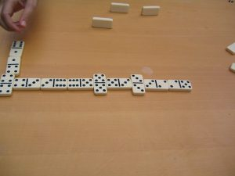
“
” by
is licensed under
Writers often use signal words or phrases to emphasize relationships between one sentence and another. Think of this as a “something old, something new” approach, meaning that the idea behind a transition is to introduce something new while connecting it to something old from an earlier point in the essay or paragraph. Here are some examples of ways that writers use connecting words (underlined below) to show connections between ideas in adjacent sentences:
To Show Similarity
When he was growing up, Aaron’s mother taught him to say “please” and “thank you” to show appreciation and respect for others. In the same way, Aaron has tried to teach the importance of manners to his own children.
Other connecting words that show similarity include also, similarly, and likewise.

To Show Contrast
Some scientists take the existence of black holes for granted; however, in 2014, a physicist at the University of North Carolina claimed to have mathematically proven that they do not exist.
Other connecting words that show contrast include in spite of, on the other hand, in contrast, and yet.

To Exemplify
The cost of college tuition is higher than ever, so students are becoming increasingly motivated to keep costs as low as possible. For example, a rising number of students are signing up to spend their first two years at a less costly community college before transferring to a more expensive four-year school to finish their degrees.
Other connecting words that show example include for instance, specifically, and to illustrate.

To Show Cause and Effect
Where previously painters had to grind and mix their own dry pigments with linseed oil inside their studios, in the 1840s, new innovations in pigments allowed paints to be premixed in tubes. Consequently, this new technology facilitated the practice of painting outdoors and was a crucial tool for impressionist painters, such as Monet, Cezanne, Renoir, and Cassatt.
Other connecting words that show cause and effect include therefore, so, and thus.

To Show Additional Support
When choosing a good trail bike, experts recommend 120–140 millimeters of suspension travel; that’s the amount that the frame or fork is able to flex or compress. Additionally, they recommend a 67–69 degree head-tube angle, as a steeper head-tube angle allows for faster turning and climbing.
Other connecting words that show additional support include also, besides, equally important, and in addition.
For more signal words and phrases, consult Transition Words & Phrases ~ Useful Lists.

A Word of Caution
Signal words and phrases can be helpful to signal a shift in ideas within a paragraph. But it’s also important to understand that these types of transitions shouldn’t be too frequent within a paragraph. Here are some examples to help you see the difference between transitions that feel like they occur naturally and transitions that seem forced and make the paragraph awkward to read:
Too Many Transitions (Awkward): The Impressionist painters of the late 19th century are well known for their visible brush strokes, for their ability to convey a realistic sense of light, and for their everyday subjects portrayed in outdoor settings. In spite of this fact, many casual admirers of their work are unaware of the scientific innovations that made it possible this movement in art to take place. Then, In 1841, an American painter named John Rand invented the collapsible paint tube. To illustrate the importance of this invention, pigments previously had to be ground and mixed in a fairly complex process that made it difficult for artists to travel with them. For example, the mixtures were commonly stored in pieces of pig bladder to keep the paint from drying out. In addition, when working with their palettes, painters had to puncture the bladder, squeeze out some paint, and then mend the bladder again to keep the rest of the paint mixture from drying out. Thus, Rand’s collapsible tube freed the painters from these cumbersome and messy processes, allowing artists to be more mobile and to paint in the open air.
Subtle Transitions that Aid Readers’ Understanding (More Natural): The Impressionist painters of the late 19th century are well known for their visible brush strokes, for their ability to convey a realistic sense of light, and for their everyday subjects portrayed in outdoor settings. However, many casual admirers of their work are unaware of the scientific innovations that made it possible for this movement in art to take place. In 1841, an American painter named John Rand invented the collapsible paint tube. Before this invention, pigments had to be ground and mixed in a fairly complex process that made it difficult for artists to travel with them. The mixtures were commonly stored in pieces of pig bladder to keep the paint from drying out. When working with their palettes, painters had to puncture the bladder, squeeze out some paint, and then mend the bladder again to keep the rest of the paint mixture from drying out. Rand’s collapsible tube freed the painters from these cumbersome and messy processes, allowing artists to be more mobile and to paint in the open air.

Transitions between Paragraphs and Sections
It’s important to consider how to emphasize the relationships not just between sentences but also between paragraphs in your essay. Here are a few strategies to help you show your readers how the main ideas of your paragraphs relate to each other and also to your thesis.

Use Signposts
Signposts are signal words or phrases that indicate where you are in the process of organizing an idea; for example, signposts might indicate that you are introducing a new concept, that you are summarizing an idea, or that you are concluding your thoughts. Some of the most common signposts include words and phrases like first, then, next, finally, in sum, and in conclusion. Be careful not to overuse these types of transitions in your writing. Your readers will quickly find them boring, repetitive, or too obvious. Instead, think of more creative ways to let your readers know where they are situated within the ideas presented in your essay. You might say, “The first problem with this practice is…” Or you might say, “The next thing to consider is…” Or you might say, “A final point to take into account is….”

Use Forward-Looking Sentences at the End of Paragraphs
Sometimes, as you conclude a paragraph, you might want to give your readers a hint about what’s coming next. For example, imagine that you’re writing an essay about the benefits of trees to the environment and you’ve just wrapped up a paragraph about how trees absorb pollutants and provide oxygen. You might conclude with a forward-looking sentence like this: “Trees benefits to local air quality are important, but surely they have more to offer our communities than clean air.” This might conclude a paragraph (or series of paragraphs) and then prepare your readers for additional paragraphs to come that cover the topics of trees’ shade value and ability to slow water evaporation on hot summer days. This transitional strategy can be tricky to employ smoothly. Make sure that the conclusion of your paragraph doesn’t sound like you’re leaving your readers hanging with the introduction of a completely new or unrelated topic.

Use Backward-Looking Sentences at the Beginning of Paragraphs
Rather than concluding a paragraph by looking forward, you might instead begin a paragraph by looking back. Continuing with the example above of an essay about the value of trees, let’s think about how we might begin a new paragraph or section by first taking a moment to look back. Maybe you just concluded a paragraph on the topic of trees’ ability to decrease soil erosion and you’re getting ready to talk about how they provide habitats for urban wildlife. Beginning the opening of a new paragraph or section of the essay with a backward-looking transition might look something like this: “While their benefits to soil and water conservation are great, the value that trees provide to our urban wildlife also cannot be overlooked.”

Evaluate Your Transitions
As you revise your draft, make sure you include transitions where you need them, and omit them where they are unnecessary. Try reading your draft aloud. Listen for areas that sound choppy or abrupt. This can help you make note of areas where transitions need to be added. Repetition is another problem that can be easier to find if you read your essay aloud. If you notice yourself using the same transitions over and over again, take time to find some alternatives.

Activity ~ Transition Strategies
Choose an essay or piece of writing, either that you’re currently working on, or that you’ve written in the past. Identify your major topics or main ideas. Then, using the suggestions in this chapter, develop at least three examples of sentence-level transitions and at least two examples of paragraph-level transitions.
Share and discuss with your classmates in small groups, and choose one example of each type from your group to share with the whole class. If you like the results, you might use them to revise your writing. If not, try some other strategies.

Is this chapter:
…too easy? –> Read “Transitioning: Beware of Velcro” from the Harvard College Writing Center.
…about right, but you would like more lists of words? –> See “Transitional Devices” from Purdue OWL.
…about right, but you would prefer to watch and learn? –> Listen to a student discuss her transitions in her paragraph in this “See It in Practice: Paragraphing” videocast from Excelsior Online Writing Lab.
This chapter was modified from “Developing Relationships between Ideas” from The Word on College Reading and Writing by Carol Burnell, Jaime Wood, Monique Babin, Susan Pesznecker, and Nicole Rosevear, which is licensed under a Creative Commons Attribution-NonCommercial 4.0 International License, except where otherwise noted.

Note: links open in new tabs.

Chapter 13

Transition Words & Phrases ~ Useful Lists
As you work on your drafts, try to use some new transition words and phrases from the lists below.
Here is a useful reference list of transition words and phrases for connections within and between paragraphs:
An interactive or media element has been excluded from this version of the text. You can view it online here:
https://pressbooks.howardcc.edu/engl087/?p=53
TRANSITION WORDS by Gregory M. Campbell, from Michael Buckhoff, adapted by John A. Dowell, is available under Creative Commons 3.0 license CC BY: Attribution.
Note: links open in new tabs.

Below is a useful handout about Transitions (ESL) that show contrast, addition, or causes and effects from the University of North Carolina at Chapel Hill’s Writing Center:

What this handout is about
Logical connectors are often listed in categories like “contrast” with no further explanation; however, there are important, though subtle differences in how they signal relationships between ideas. This handout will help you choose the appropriate connector by explaining how some of the more common expressions function to connect ideas.

Contrast transitions
Expression | Function | Example
In contrast |  | Northern regions experienced record snowfall last year. In contrast, southern regions had one of the mildest winters on record.NOT: I’ve had breakfast; in contrast, I’m still hungry.
However | Shows contrast between comparable things or between expectation and realitySynonymous with “but” and “despite this” | Northern regions experienced record snowfall last year. However, southern regions had one of the mildest winters on record. (contrasting two similar things)The research clearly shows the risks. However, incidence of smoking is increasing rapidly in developing countries. (contrasting expectation and reality)
On the contrary | Opposition (not x but y).Follows a negative statement and elaborates | The island was nothing like the tropical paradise we had expected. On the contrary, it was noisy, dirty, and completely unrelaxing!(In academic writing, the phrase “contrary to” is far more common: Contrary to the tropical paradise we had expected, the island was noisy, dirty, and completely unrelaxing.)
On the other hand | Comparison of two choices or two sides of an issue | Buying lottery tickets is probably a waste of money. On the other hand, it might be the best investment you could ever make!
Nevertheless, Nonetheless | Shows contrast between expectation and realitySynonymous with “but” and “despite this” | The research clearly shows the risks. Nevertheless, incidence of smoking is increasing rapidly in developing countries.I’ve had breakfast; nevertheless, I’m still hungry.

Addition transitions
Expression | Function | Example
Also | Almost interchangeable with “and.” Prefers identical subjects and usually appears after the subject. | The community is working to meet the needs of its citizens. The Town Council has just authorized a new senior center for the elderly. It has also implemented new social programs for teens and will be discussing a pre-school program at the next meeting.
Besides | Used as a transitional adverb, “besides” adds information emphatically. It implies that previous information can be disregarded because the new information is so powerful. | I’m not planning to accept the job at Harvard. It doesn’t offer enough research funding, and Boston is too cold for me. Besides, I’ve already accepted a position at UNC.
Besides that | Adds information emphatically, but does not imply that previous information can be disregarded. (Compare to “besides” above.) | I’m not planning to accept the job at Harvard. It doesn’t offer enough research funding, and Boston is too cold for me. Besides that, there will be very few people to collaborate with, so UNC is the best choice overall.
Furthermore | Usually used when three or more reasons (or premises) are given for the same conclusion | Moderate exercise has many beneficial effects. It lowers blood pressure, reduces weight, and improves overall muscle tone. Furthermore, it has the added benefit of releasing endorphins, generally improving the mood of those who exercise.
In addition, Additionally | More formal than “and.” Used for joining sentences. Prefers non-identical subjects and appears before the subject. | The community is working to meet the needs of its citizens. The Town Council has just authorized a new senior center for the elderly. In addition, the Parks Department has instituted a summer arts program for teens.
In addition to | Use when adding a noun phrase to a sentence. Verbs in this phrase take the -ing form. | In addition to building a new senior center for the elderly, the community has implemented a free senior transportation system.In addition to the new senior center, there is a new transportation system.
Moreover | Usually used when two or more reasons (or premises) are given for the same conclusion | The Senator’s remarks have outraged the liberals; moreover, they have alienated the conservatives. He will surely suffer in the next election.

Cause-Effect transitions
Expression | Function | Example
Consequently | Signals causal relationship | He was absent over 50% of the time and missed the final exam. Consequently, he failed the course.
Therefore | Signals causal relationship. Also signals a logical conclusion or reasonable inference. | He was absent over 50% of the time and missed the final exam. Therefore, he failed the course.He has failed several courses this year. Therefore, I think it’s likely that he’ll change his major.
For this/that reason | Signals causal relationship when reason is explicitly stated. | She was an excellent intern last summer. For this reason, I’m willing to hire her for the new full-time position.
Hence, Thus | Same as “therefore” but more formal. Both of these can be used to introduce phrases rather than complete sentences. | The grant is nearing the end of its cycle. Thus, we’re actively seeking funding.The grant is nearing the end of its cycle. Hence, the search for new funding.
In that case | Signals a conditional relationship, like if–>then | Water may reach flood stage by morning. In that case (if that happens), the National Guard will come to assist.
This work is licensed under a
.
You may reproduce it for non-commercial use if you use the entire handout and attribute the source: The Writing Center, University of North Carolina at Chapel Hill

Chapter 14

Rhetorical Modes for Paragraphs & Essays

Questions to Ponder
Before you read this chapter, discuss with partners:
- What are rhetorical modes (also called “patterns of organization” and “methods of development”)? Can you list some examples?
- Why are rhetorical modes important in writing? Jot down your ideas.



“
” by
from
is in the
Now read the graphic below. Can you add to the list of rhetorical modes that you created with your partners?
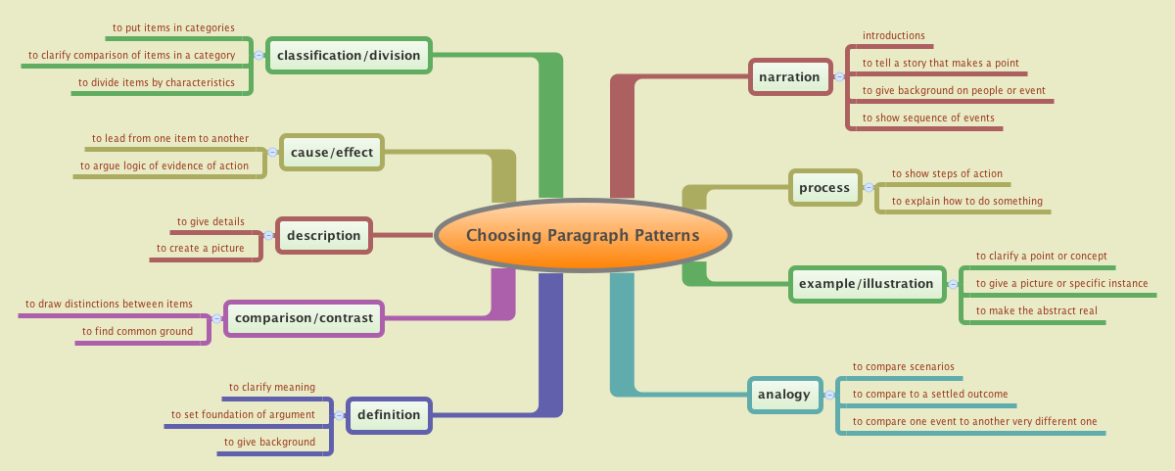
Image of “Choosing Paragraph Patterns.” Authored by: GrinnPidgeon. Located at: https://flic.kr/p/a9oiLS and reproduced in Lumen’s
License:

Rhetorical Modes
Rhetorical modes are also called patterns of organization or methods of development; they are the ways that authors and speakers organize their ideas to communicate effectively. The rhetorical modes that are covered here are best used as ways to look at what’s already happening in your draft and to consider how you might emphasize or expand on any existing patterns. You might already be familiar with some of these patterns because instructors will sometimes assign them as the purpose for writing an essay. For example, you might have been asked to write a cause and effect essay or a comparison and contrast essay.
Patterns of organization or methods of developing content usually happen naturally as a consequence of the way the writer engages with and organizes information while writing. That is to say, most writers don’t sit down and say, “I think I’ll write a cause and effect essay today.” Instead, a writer might be more likely to be interested in a topic, say, the state of drinking water in the local community, and as the writer begins to explore the topic, certain cause and effect relationships between environmental pollutants and the community water supply may begin to emerge. And in fact, many times, one essay may incorporate two or more rhetorical modes, as the author makes an argument for their point of view.

Activity A ~ Brainstorming Rhetorical Modes
Pause here to brainstorm ideas with your partner. Using the chart above (“Choosing Paragraph Patterns“), discuss some of the topics below. Which mode(s) might you use in an essay about these topics? Would you need to explore more than one rhetorical mode for each topic?
- Gender roles
- Race in America
- The value of art in society
- Travel as part of a well-rounded education
- Drugs and alcohol
- Advice to new parents
- Advice to teachers
- The value of making mistakes
- How you’d spend a million dollars
- What a tough day at work taught you about yourself or others
- My family history
- Your idea: ___________
Keep reading to consider some of the ways that these strategies can help you as you revise a draft.

Cause/Effect
Do you see a potential cause-and-effect relationship developing in your draft? The cause/effect pattern may be used to identify one or more causes followed by one or more effects or results. Or you may reverse this sequence and describe effects first and then the cause or causes. For example, the causes of water pollution might be followed by its effects on both humans and animals. Use the signal words cause, effect, and result, to cue the reader about your about the relationships that you’re establishing.
Here’s an example article from The New York Times, “Rough Times Take Bloom Off a New Year’s Rite, the Rose Parade,” that explores the cause and effect relationship (from 2011) between Pasadena’s budgetary challenges and the ability of their Rose Parade floats to deck themselves out in full bloom.

Problem/Solution
At some point does your essay explore a problem or suggest a solution? The problem/solution pattern is commonly used in identifying something that’s wrong and in contemplating what might be done to remedy the situation. For example, the problem of water pollution could be described, followed by ideas of new ways to solve the problem. There are probably more ways to organize a problem/solution approach, but here are three possibilities:
- Describe the problem, followed by the solution
- Propose the solution first and then describe the problems that motivated it
- Explain a problem, followed by several solutions, and select one solution as the best
Emphasize the words problem and solution to signal these sections of your paper for your reader.
Here’s an example article from The New York Times, “Monks Embrace Web to Reach Recruits,” that highlights an unexpected approach by a group of Benedictine monks in Rhode Island; they’ve turned to social media to grow their dwindling membership.

Compare/Contrast
Are you trying to define something? Do you need your readers to understand what something is and what it is not? The compare-and-contrast method of development is particularly useful in extending a definition, or anywhere you need to show how a subject is like or unlike another subject. For example, the statement is often made that drug abuse is a medical problem instead of a criminal justice issue. An author might attempt to prove this point by comparing drug addiction to AIDS, cancer, or heart disease to redefine the term “addiction” as a medical problem. A statement in opposition to this idea could just as easily establish contrast by explaining all the ways that addiction is different from what we traditionally understand as an illness. In seeking to establish comparison or contrast in your writing, some words or terms that might be useful are by contrast, in comparison, while, some, and others.
Here’s an example article from The New York Times “Who Wants to Shop in a Big Box Store, Anyway?” The author explores some interesting differences between the average American and average Indian consumer to contemplate the potential success of big box stores in India and also to contemplate why these giant big box corporations, like Walmart or Target, might have to rethink their business model.

Umbrella by
on
These three methods of development—cause/effect, problem/solution, and compare/contrast—are just a few ways to organize and develop ideas and content in your essays. It’s important to note that they should not be a starting point for writers who want to write something authentic, to discuss something that they care deeply about. Instead, they can be a great way to help you look for what’s already happening with your topic or in a draft, to help you to write more, or to help you reorganize some parts of an essay that seem to lack connection or feel disjointed.
Sometimes writers incorporate a variety of modes in any one essay. For example, under the umbrella of an argument essay, and author might choose to write paragraphs showing cause and effect, description, and narrative. The rhetorical mode writers choose depends on the purpose for writing. Rhetorical modes are a set of tools that will give you greater flexibility and effectiveness in communicating with your audience and expressing ideas.
In addition to cause/effect, problem/solution, and compare/contrast, there are many other types of rhetorical modes:
- Classification and division, often used in science, takes large ideas and divides them into manageable chunks of information, classifying and organizing them into types and parts.
- Definition clarifies the meaning of terms and concepts, providing context and description for deeper understanding of those ideas.
- Description provides detailed information using adjectives that appeal to the five senses (what people see, hear, smell, taste, and touch) as well as other vivid details that help readers visualize or understand an item or concept.
- Evaluation analyzes and judges the value and merit of an essay, a concept, or topic.
- Illustration provides examples and evidence in detail to support, explain, and analyze a main point or idea.
- Narrative uses fictional or nonfictional stories in a chronological sequence of events, often including detailed descriptions and appeals to the senses and emotions of readers while storytelling to reveal a theme or moment.
- Persuasion (i.e., argumentation) logically attempts to convince readers to agree with an opinion or take an action; the argument also acknowledges opposing viewpoints and accommodates and/or refutes them with diplomatic and respectful language, as well as provides precise and accurate evidence and other expert supporting details.
- Process analysis describes and explains, step by step, chronologically, in detail, and with precision and accuracy, how to do something or how something works.
Assignment prompts for college essays may require a specific rhetorical mode, or you may be able to choose the best mode(s) to express your ideas clearly. Either way, be sure to ask your instructor if you are not sure which rhetorical mode(s) to use.

Key Takeaways
Why are rhetorical modes important?
- As readers, understanding an author’s rhetorical mode helps us to understand the text, and to read and think critically.
- Knowing the rhetorical mode helps us to identify the author’s main ideas, which helps us to summarize the author’s work.
- As writers, we use rhetorical modes to make our writing clearer; they help us signal our topic and direction to our readers.
- Rhetorical modes also help us to develop support and keep our readers interested.

Activity B ~ Identifying Rhetorical Modes
- Read a printed or online essay or article. A letter to the editor or an editorial from a newspaper would be perfect. Then, with a partner, identify the modes of writing found in the article. (Use the lists above to help.) Analyze the different choices the writer has made about language and organization to express a point of view. Notice how the author may combine rhetorical modes (for example, a problem-solution article that uses cause-and-effect organization in some paragraphs, or a definition pattern that uses narrative or compare and contrast paragraphs to develop similarities or differences).
- Select, read, and annotate a sample student essay in a specific style as provided in “Readings: Examples of Essays” from Saylor Academy. Note in the margins or on another sheet of paper what rhetorical mode each paragraph uses, how those modes and paragraphs support the overall rhetorical mode of the essay, and whether each paragraph does so successfully or not. Discuss in small groups and summarize your findings to report to the rest of the class.

…too easy, or you would like more information? Read “
” from Lumen’s English Composition course.
…too general? Scroll through
on writing particular types of essays.
If you want to learn more about three common rhetorical modes, read what the New York Times has to say in their learning blog article, “Compare-Contrast, Cause-Effect, Problem Solution: Common ‘Text Types’ in The Times.”
Note: links open in new tabs.

This chapter was modified from the following Open Educational Resources:
“Patterns of Organization and Methods of Development” from The Word on College Reading and Writing by Carol Burnell, Jaime Wood, Monique Babin, Susan Pesznecker, and Nicole Rosevear, which is licensed under a Creative Commons Attribution-NonCommercial 4.0 International License.

“Introduction” from English Composition by Karyl Garland, Ann Inoshita, Jeanne K. Tsutsui Keuma, Kate Sims, and Tasha Williams, is licensed under a Creative Commons Attribution 4.0 International License

“Chapter 10: The Rhetorical Modes” and “Chapter 15: Readings: Examples of Essays,” from Writing for Success from Saylor Academy, which is licensed under Creative Commons Attribution-NonCommercial-ShareAlike 3.0.

Chapter 15

Essays ~ Choosing the Best Structure

Federica EspositoUnsplash | Xiaofen PUnsplash | matthaeusUnsplash

Questions to Ponder ~ Your Dream Home
With a small group, discuss your “dream home.” What does it look like? Where is it? What material is it made of? Who lives there? What is the environment like outside the house? Search for some images of homes that appeal to you.
Can you compare and contrast the homes you and your partners chose? Can you make an argument for why your choice is the best?

As you begin to write an essay, you will need to think about the best structure for your ideas. Building an essay is like building a house: you need to think about audience (who will live in the house?), purpose (what will they do in the house?) and context (what in the environment like around the house?).
When you write an essay, you need to make decisions about what kind of structure is best to express your ideas clearly, and to meet the requirements of the assignment. It helps to think about your audience, purpose, and context as you consider your options.

Traditional Essay Format
One useful essay structure is the traditional 5-paragraph format. This format is typically taught in U.S. high schools. A 5-paragraph essay starts with an Introduction, which includes a thesis statement. The thesis statement often includes 3 controls, which are the points the writer intends to develop in the essay.
After the Introduction, there are three Body Paragraphs, which each start with a topic sentence. Each topic sentence introduces one of the controls from the thesis.
Finally, the Conclusion paragraph re-states the original thesis and leaves the reader with a final thought.
This format can be very useful when you start to practice writing an American English essay. Depending on the assignment prompt and/or the context, a 5-paragraph essay may be a good choice for ENGL 087. For example, if you are writing a timed, in-class essay, the 5-paragraph structure may be very useful. Or, if the assignment prompt asks you to explain three causes of obesity, the 5-paragraph structure might work. In these cases, your essay and your classmates’ essays may have similar points, and they will have the same structure. The 5-paragraph format can also be useful in standardized writing situations like TOEFL and IELTS.

College Essay Formats
However, many college instructors will expect your writing to go beyond the 5-paragraph structure. College professors expect you to think critically about your topic, not just write facts about it. They also expect you to take a stand about the topic, and to conduct research to support your ideas. In these cases, your essay and your classmates’ essays will probably be very different, even if your opinions are similar. Your essay will explain your unique opinion and ideas about the topic, in your own style. This is what makes college writing so interesting – for both the writer and the readers.
A strong college essay does incorporate some of the features of a 5-paragraph essay. For instance, a good Introduction will help open your essay. A catchy “hook” at the beginning will grab your readers’ attention and make them interested in reading your essay. Next, some background information can be useful, to explain more about your topic. A clear thesis statement here is very helpful to your readers – in a U.S. classroom, readers do not want to “hunt” for your overall main idea. For ENGL 087, most essays will require a one-paragraph Introduction. Longer essays for your future classes may need a longer Introduction.
After your Introduction paragraph, the Body Paragraphs will explain your main ideas. Use as many Body Paragraphs as you need to develop and explain your main ideas. Topic sentences can help main your main points clear. There is no “right” or “wrong” length for the Body Paragraphs; one guideline for college essays is to have paragraphs take two-thirds to three-fourths of a page, but they can be shorter or longer.
Your Conclusion paragraph should remind readers about your thesis. You should also leave your reader with a final thought, as in the traditional 5-paragraph essay. The kind of final thought will depend on the assignment prompt.
Here is a a general outline for a strong ENGL 087 essay. You can adapt this as you need to, depending on the assignment prompt:
I. Introduction
A. Hook
B. Background information
C. Thesis
II. Body Paragraph
A. Topic sentence
1. supporting detail
2. supporting detail
(add as many supporting details as you need)
3. connection to next paragraph
III. (add as many Body Paragraphs as you need)
IV. Conclusion
A. reminder of thesis (re-state your thesis in a new way – do not just copy your original thesis here)
B. final thought (examples: call to action, opinion, rhetorical question, proposal, or prediction)
In some ways, this more open-ended college essay format is more challenging, because it does not provide a rigid structure for you to follow. But that is what makes it more interesting to write and to read: because it is not following a formula, you are free to develop and connect your ideas as you wish. You can build your “dream essay” without trying to fit ideas into a specific formula. It’s your choice as the author to decide which structure is the best for your purpose.

Is this chapter:
…about right, but you would like more examples? –> Read “The Transition from High School to College Writing” from the University of Toronto’s UC Writing Centre. Also see “Types of Essays and Suggested Structures” from Lumen’s Developmental English: Introduction to College Composition.
…too easy, or you would like more evidence for why the 5-paragraph format is not always effective? –> Read “College Writing” from University of North Carolina at Chapel Hill’s Writing Center and the module entitled “Why It Matters: Beyond the 5-Paragraph Essay” from Lumen’s Writing Skills Lab.
For more on the differences between 5-paragraph essays and less rigid structures, consult “Formulaic vs. Organic Structure” from Lumen’s Writing Skills Lab.
Note: links open in new tabs.

Chapter 16

Introductions & Titles
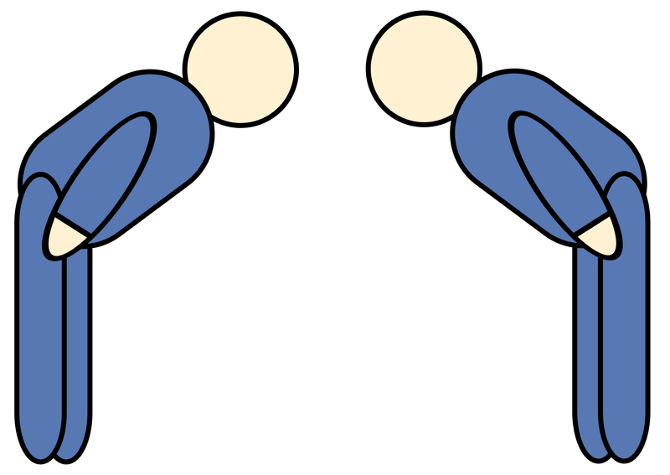
<a href=”http://Photo via
” target=”_blank” rel=”noopener noreferrer”>two people bowing from

Photo by
on

Questions to Ponder
Discuss these questions with your partners: What is happening in the pictures above? How do you introduce yourself to someone new? Are introductions the same in every situation? Describe the differences to your partners.
Your Title and Introduction are your first chance to make a positive impression on your audience. You want to get your readers’ attention, state your main point, and establish your credibility as an author. In this first section, we will discuss Introductions; the end of the chapter includes brief advice about writing Titles.

Drafting Powerful Introductions
Once you know what your essay will be about, and you have a some ideas for your thesis, you can begin to draft your Introduction. Some writers like to start with the Introduction; some like to begin with the Body Paragraphs. As you practice writing more essays, you will discover what approach works best for you.
There may be times when you are very certain of your thesis, and so you can start with your Introduction. Often, however, in academic writing, it is better to start with an open mind as you read and conduct research about your topic. You may find that you change your mind – and your original idea for your thesis – as you do your research. In that case, you may choose to start drafting Body Paragraphs to learn more, and then work on your Introduction later.
A good Introduction will usually provide these three things:
- a catchy “hook” to open your essay and grab your readers’ interest in the first sentence or two
- background information about your topic
- a clear thesis statement that provides your topic and shows the direction your essay will take
Typically, in an ENGL 087 essay, the Introduction is one paragraph. In longer college essays, you may need more than one paragraph.

Drafting Hooks
The opener, or “hook,” for your essay is, along with your title, a first chance to grab your readers’ interest and attention. This first sentence should make your readers want to read and learn more about your topic. There are many ways to open your essay effectively; here are some suggestions:
- a surprising statistic
- a personal anecdote
- an interesting quotation from an expert
- a thought-provoking question
Remember your audience as you draft some possible hooks to use. In your opener, try to avoid:
- obvious statements or well-known facts
- over-used expressions like “Since the beginning of time, people have…”
- over-used questions for common topics (“Have you ever wondered about global warming?” is not a catchy hook. “Have you ever gone scuba-diving with sharks?” on the other hand, might grab your audience’s attention.)

Drafting Background Information
Once you have your readers’ attention, you need some sentences to provide background information about your topic. These sentences explain more about your topic, and they lead your reader from the opening hook to the thesis. Again here, remember your audience as you draft your background information. What will your audience already know? Avoid re-explaining things that would be obvious to your reader. People will want to read your essay to learn something new, not to read something they already know.
The background information should be related in some way to your opener, and it should lead your reader to your thesis statement. It can be general information about your topic, data, or a personal story – something that connects your hook to your thesis.

Activity A ~ Analyzing Hooks & Background
One way to improve your Introduction-writing skills is to look at different choices that other writers make when introducing a topic and to consider what catches your interest as a reader and what doesn’t. Read the pieces of Introductions below about teenagers and decision making. Which ones pull you in? Which ones are less interesting? What’s the difference? What’s missing? Work with your partners to decide. Which would be best for a formal college essay?
- Throughout history, teenagers have challenged the authority of adults. They do this because they want to be given more freedom and to be treated like adults themselves. This can cause real problems between teens and the adults in their lives.
- Some days my sixteen-year-old niece, Rachael, does all of her homework, helps friends study after school, and practices her cello, and other days she forgets her books at school, lies about where she’s going, and doesn’t do her chores. This sporadic behavior seems like it comes out of nowhere, but it turns out teenage brains are different from adult brains, causing teens to sometimes not think about consequences before they act.
- If teenage brains aren’t fully formed, causing them to act before they think about the risks they’re taking, should teens be restricted from some adult freedoms like driving, working, and socializing without adult supervision?
- Teenagers are known to be less responsible than adults, so they should have at least some adult guidance to make sure they stay safe. Without adult supervision, teens will make poor decisions that could put them at unnecessary risk.
- According to the American Academy of Child and Adolescent Psychiatry, the frontal cortex in the brain, where reasoning and thinking before acting occurs, is not fully formed in teenagers. However, the amygdala, “responsible for immediate reactions including fear and aggressive behavior,” is fully formed early in life. This means teens aren’t as good at considering the consequences of their behavior before they react, so the adults in their lives should limit the risks in their lives until they’re better able to reason through them. (Note: an in-text citation would be needed after the direct quotation in this example.)

Drafting Thesis Statements
A thesis statement is often in the final sentence or two of the Introduction.
A strong thesis statement will:
- tell your readers your overall main idea, including your point of view about the topic
- make a claim about your topic and show your purpose for writing the essay
In other words, after reading your thesis statement, your audience should understand what you will write about and why the topic is important.
You may choose to write a thesis without the main ideas (sometimes called “controls”) of your essay:
Because illegal drug sales continue to increase, communities should do more to combat this problem.
Or you may choose to include the specific points your essay will discuss:
Because illegal drug sales continue to increase, communities should do more to combat this problem by forming neighborhood watch organizations and supporting their local police forces.
In both examples, it is clear that the author will write about what communities should be doing because the sale of illegal drugs is on the rise; both thesis statements show the what and the why of the essay.
In ENGL 121, you will learn more about developing an argument in your college essays. For most academic essays, your thesis will need to have a claim that is debatable – not one that is obvious. Here are some examples:
Junk food is bad for your health is not a debatable thesis. Most people would agree that junk food is bad for your health.
Because junk food is bad for your health, the size of sodas offered at fast-food restaurants should be regulated by the federal government is a debatable thesis. Reasonable people could agree or disagree with the statement.
Federal immigration law is a tough issue about which many people disagree is not an arguable thesis because it does not assert a position.
Federal immigration enforcement law needs to be overhauled because it puts undue constraints on state and local police is an argumentative thesis because it asserts a position that immigration enforcement law needs to be changed.
An effective thesis is also specific. If your thesis is too general, you will need to write a very long essay or book to defend your point of view. Instead, try to narrow your focus, as in this example:
The federal government should overhaul the U.S. tax code is not an effective argumentative thesis because it is too general (What part of the government? Which tax codes? What sections of those tax codes?) and would require an overwhelming amount of evidence to be fully supported.
The U.S. House of Representative should vote to repeal the federal estate tax because the revenue generated by that tax is negligible is an effective argumentative thesis because it identifies a specific actor and action and can be fully supported with evidence about the amount of revenue the estate tax generates.
In your thesis drafts, try to avoid “writing about writing,” as in:
In this essay, I will argue that communities should take more action to protect themselves.
Instead, just get straight to the point:
Communities should take more action to protect themselves.
Try also to avoid hedging and redundancy, as in:
In my opinion, I believe that all children should have free health care.
The preferred approach is to state your position directly:
The government should provide all children with free health care.
Note: Hedging can be very effective in other places in your essay; for instance, when you want to show that you are open-minded about a topic, you may choose to use this technique by using words like possible, likely, suggest, and so on. A strong thesis, however, is usually more direct.
As you draft your essay, a working thesis can be very helpful. A working thesis is a work in progress; it is an initial draft of your thesis. You may draft and re-write your working thesis several times as you write and conduct research for an essay. This shows good scholarship; it means that you are keeping an open mind and that you are learning and considering new ideas as you do your research.

- Examine these working thesis statements. All of these are problematic in some way. What advice would you give the writer? Are the thesis statements debatable? Are they too obvious or too general? Do they use too much “writing about writing,” hedging, or redundancy? With your partner, write an improved thesis statement for each example.
  - Prisons in the United States are overcrowded.
  - In the following essay, I will discuss the problem of overcrowding in U.S. prisons, and I will propose solutions for this problem.
  - According to my opinion, firefighters and other first responders should have better salaries and health care.
  - Health care providers often suffer from stress because they are overworked and underpaid.
  - I think that students should be allowed to use cell phones in their classes.
  - It might be a good idea for children to have pets.
  - American pre-schoolers eat too much sugar.
  - There are many causes and effects of climate change, which I will discuss in the following paper.

Activity B – Fixing Problematic Thesis Statements

Activity C ~ Practice Writing Introductions
Now that you’ve had an opportunity to think about some different approaches and techniques for writing Introductions, try some practice writing. Choose a draft of an assignment you have created this term and use what you’ve learned in this section to write an attention-getting Introduction to your piece.
For more practice, you can write an Introduction using one of the following scenarios. Read through the following list and choose one. Write as much as you can for a possible Introduction.
- Persuade your readers to visit your country.
- Persuade students to learn a foreign language before they graduate from college.
- Give some tips to new parents that will help lower their stress and make their new baby feel safe and loved.
- Review a movie, book, product, or trip for someone thinking of making one of these purchases to help them decide that they should or shouldn’t do it.
Share your Introduction with your classmates and discuss what about it is effective and how it could be improved.

Drafting Titles
Often, the title of your essay will be the last thing you finalize. You can start with a working title, which is an initial attempt at capturing your essay’s main ideas. As you draft and revise your essay, you will want to revise your working title; it will change over time as your essay develops. A good title will be short and interesting; this is your very first chance to grab your readers’ attention. Be sure your title relates closely to your thesis and draws your reader in.
See MLA Formatting Guides for information on formatting your essay title.
Is this chapter:
…too easy? –> Read “Developing a Thesis” from Harvard’s Writing Center.
…about right, but you would like to read more? –> Check “Introductions and Conclusions” from University of Toronto. See also “Introductions” from Lumen’s Writing Skills Lab and “Parts of a Thesis Sentence” from Excelsior’s OWL for sample pieces of Introductions.
…about right, but you would like to listen to a student-writer as she drafts a working thesis? –> Watch “See It in Practice: Argumentative Thesis” from Excelsior OWL.
For more practice, try “Practice in Identifying Effective Thesis Statements” from ThoughtCo.
Activities in this chapter were adapted from “Writing Introductions” from The Word on College Reading and Writing by Carol Burnell, Jaime Wood, Monique Babin, Susan Pesznecker, and Nicole Rosevear, which is licensed under a Creative Commons Attribution-NonCommercial 4.0 International License, except where otherwise noted.

Some examples (“junk food” through “U.S. House”) were from “Argumentative Thesis Statements” in Lumen’s Writing Skills Lab; they appeared originally as: Argumentative Thesis Statements. Provided by: University of Mississippi. License: CC BY: Attribution

Note: links open in new tabs.

Chapter 17

Conclusions

blue wrapped present by
from
is in the
An effective Conclusion wraps up your conversation about the topic, and leaves your readers with a final thought. This is your last chance to drive home your main ideas.
Here are some strategies to wrap up your conversation:
- Re-connect to your opener. If you started your essay with an anecdote, for instance, consider re-visiting that story, or finishing the ending of it. If you started your essay with a question, perhaps you could provide a possible answer in your Conclusion. If you started with a statistic or quotation, maybe inserting a related statistic or quotation here would work well.
- Remind your readers about your thesis. This may feel redundant or obvious to you, but it is common in the U.S. for writers to re-state the main point in a fresh way in the Conclusion. You can summarize your main ideas here in 1-2 sentences.
Because you are an author contributing to a scholarly conversation, your Conclusion should also leave your readers with a final thought. This is a way for them to enter into the conversation with you, as when you ask your audience if they have questions when you give a speech.
Here are some strategies to leave your readers with a final thought:
- Invite your readers to do something. This is a “call to action.”
- Ask a new question for your readers to ponder – one that is related to your essay, but that re-frames your idea in a different way.
- Remind your readers WHY your idea is important.
- Make a prediction about your topic.
- Recommend further reading or analysis of your topic.
As always, consider your audience as you draft your Conclusion. What would appeal to your readers? What would be reasonable to ask them to do?
Here are some examples:
call to action:
Citizens who agree that music education should be a part of all public schools in the United States can make a difference by writing their representatives, going to a school board meeting, and when a ballot initiative comes around, voting to fund music education.
question to ponder:
Should schools in the U.S. be concerned with the kind of emotional and cognitive development that music education prompts? If we’re interested in educating the whole child, not just the most academic parts of the brain, then the answer is yes, and we have to reconsider our priorities when it comes to school funding.
quotation from an expert:
As Oliver Sacks notes in his book Musicophilia, “Rhythm and its entrainment of movement (and often emotion), its power to ‘move’ people, in both senses of the word, may well have had a crucial cultural and economic function in human evolution, bringing people together, producing a sense of collectivity and community” (268). Our schools aim to foster that same sense of community, which is why music must be part of a well rounded education.
It may be tempting to start with “In conclusion, I have…” or “To sum up,…” as transitions into your Conclusion paragraph. But your readers can tell that your essay is nearly done – they see just one paragraph on the screen or paper, so they know this final paragraph is your Conclusion; there is no need to add that “writing about writing.” A more elegant way to finish is to make sure the ideas in your final Body Paragraph connect to your Conclusion.
Note: You can draft and revise your Introduction and Conclusion at any point during your essay-writing process. Just be sure to re-visit the Introduction and Conclusion at the very end of your process, and ask yourself:
- Do my Introduction and Conclusion match? That is, am I consistent with my main idea? (Often, as we write and conduct research, our ideas and points of view can change. It’s important to make sure that you have updated both your Introduction and Conclusion so that you are not contradicting yourself in your essay.)

Activity A ~ Analyzing Conclusions
One way to improve your conclusion-writing skills is to look at different choices that other writers make when concluding a topic and to consider what feels satisfying or thought-provoking to you as a reader and what doesn’t. Read the conclusions below about teenagers and decision making. Which ones pull you in? Which ones are less interesting? What’s the difference? What’s missing? Discuss with a small group.
- Should teens be given complete freedom? Probably not, but a measured level of responsibility helps kids of all ages learn to trust themselves to make good decisions. This is especially important for teens since they will be adults very soon.
- Parents who want to teach their teenagers to be responsible decision makers can start by talking to their teens regularly about the kinds of decisions their teens are being faced with and allowing teens to make decisions about anything that won’t put them in immediate danger. This may be difficult at first, but the reward will come when parents see their teens feeling more confident in the face of difficult decisions and more ready to face the adult world.
- As stated above, research shows that the teenage brain isn’t fully matured, so adults should consider this when deciding how much freedom to give them.
- According to the AACAP, teens are more likely to make decisions based on emotions without thinking first. This means they’re more likely to “engage in dangerous or risky behavior.” Therefore, teens need to be protected until they’re old enough to make thoughtful decisions.
- Now that Rachael has been given the freedom to make some big decisions in her life, she’s more willing to talk to her parents when she needs advice or isn’t sure about something. Even though she sometimes makes mistakes, her parents trust that she will learn important lessons from those mistakes, and they help her feel supported when she experiences a failure. Raising a teenager isn’t easy, but this family has found a method that’s working for this particular teen.

Activity B~ Writing Conclusions
Now that you’ve had an opportunity to think about some different approaches and techniques for writing Conclusions, try some practice writing. Choose a writing assignment you have created this term and use what you’ve learned in this section to write a compelling Conclusion to your piece.
For more practice, write a Conclusion using one of the scenarios below. Read through the following list and choose one. (You may want to match the one you chose in the Introductions chapter.) Then, practice writing a concluding statement or paragraph on the topic.
- Persuade your readers to visit your country.
- Persuade students to learn a foreign language before they graduate from college.
- Give some tips to new parents that will help lower their stress and make their new baby feel safe and loved.
- Review a movie, book, product, or trip for someone thinking of making one of these purchases to help them decide that they should or shouldn’t do it.
Share your Conclusion with your classmates and discuss what about it is effective and how it could be improved.

Is this section:
…too easy, or you would like more detail? –> Consult “Ending the Essay: Conclusions” from the Harvard College Writing Center.
…about right, but you would like to read more? –> Check “Introductions and Conclusions” from University of Toronto.
Examples and activities in this chapter were adapted from “Writing Conclusions” from The Word on College Reading and Writing by Carol Burnell, Jaime Wood, Monique Babin, Susan Pesznecker, and Nicole Rosevear, which is licensed under a Creative Commons Attribution-NonCommercial 4.0 International License, except where otherwise noted.


Note: links open in new tabs.

Chapter 18

Argument, Counterargument, & Refutation
In academic writing, we often use an Argument essay structure. Argument essays have these familiar components, just like other types of essays:
- Introduction
- Body Paragraphs
- Conclusion
But Argument essays also contain these particular elements:
- Debatable thesis statement in the Introduction
- Argument – paragraphs which show support for the author’s thesis (for example: reasons, evidence, data, statistics)
- Counterargument – at least one paragraph which explains the opposite point of view
- Concession – a sentence or two acknowledging that there could be some truth to the Counterargument
- Refutation (also called Rebuttal) – sentences which explain why the Counterargument is not as strong as the original Argument
Consult Introductions & Titles for more on writing debatable thesis statements and Paragraphs ~ Developing Support for more about developing your Argument.
Imagine that you are writing about vaping. After reading several articles and talking with friends about vaping, you decide that you are strongly opposed to it.
Which working thesis statement would be better?
Vaping should be illegal because it can lead to serious health problems.
Many students do not like vaping.
Because the first option provides a debatable position, it is a better starting point for an Argument essay.
Next, you would need to draft several paragraphs to explain your position. These paragraphs could include facts that you learned in your research, such as statistics about vapers’ health problems, the cost of vaping, its effects on youth, its harmful effects on people nearby, and so on, as an appeal to logos. If you have a personal story about the effects of vaping, you might include that as well, either in a Body Paragraph or in your Introduction, as an appeal to pathos.
A strong Argument essay would not be complete with only your reasons in support of your position. You should also include a Counterargument, which will show your readers that you have carefully researched and considered both sides of your topic. This shows that you are taking a measured, scholarly approach to the topic – not an overly-emotional approach, or an approach which considers only one side. This helps to establish your ethos as the author. It shows your readers that you are thinking clearly and deeply about the topic, and your Concession (“this may be true”) acknowledges that you understand other opinions are possible.
Here are some ways to introduce a Counterargument:
- Some people believe that vaping is not as harmful as smoking cigarettes.
- Critics argue that vaping is safer than conventional cigarettes.
- On the other hand, one study has shown that vaping can help people quit smoking cigarettes.
Your paragraph would then go on to explain more about this position; you would give evidence here from your research about the point of view that opposes your own opinion.

Here are some ways to begin a Concession and Refutation:
- While this may be true for some adults, the risks of vaping for adolescents outweigh its benefits.
- Although these critics may have been correct before, new evidence shows that vaping is, in some cases, even more harmful than smoking.
- This may have been accurate for adults wishing to quit smoking; however, there are other methods available to help people stop using cigarettes.
Your paragraph would then continue your Refutation by explaining more reasons why the Counterargument is weak. This also serves to explain why your original Argument is strong. This is a good opportunity to prove to your readers that your original Argument is the most worthy, and to persuade them to agree with you.

Activity ~ Practice with Counterarguments, Concessions, and Refutations
A. Examine the following thesis statements with a partner. Is each one debatable?
B. Write your own Counterargument, Concession, and Refutation for each thesis statement.
Thesis Statements:
- Vaping should be illegal because it can lead to serious health problems.
- Online classes are a better option than face-to-face classes for college students who have full-time jobs.
- Students who engage in cyberbullying should be expelled from school.
- Unvaccinated children pose risks to those around them.
- Governments should be allowed to regulate internet access within their countries.

Is this chapter:
…too easy, or you would like more detail? Read “Further Your Understanding: Refutation and Rebuttal” from Lumen’s Writing Skills Lab.
Note: links open in new tabs.

Chapter 19

Ethos, Pathos, & Logos

Using Rhetorical Appeals to Support Your Argument
In addition to choosing an effective rhetorical mode (see Rhetorical Modes for Paragraphs & Essays for details) for an essay, you need to think about the most effective rhetorical appeal, or way of persuading your audience.
Writers are generally most successful with their audiences when they can skillfully and appropriately balance the three core types of rhetorical appeals. These appeals are referred to by their Greek names: ethos, pathos, and logos.

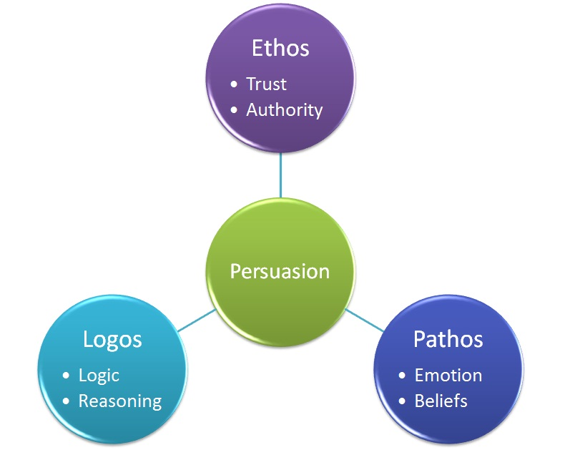

Authoritative Appeals = Ethos
Authors using authority to support their claims can use a variety of techniques. These include the following:
- personal anecdotes
- proof of deep knowledge on the issue
- citation of recognized experts on the issue
- testimony of those involved first-hand on the issue

Emotional Appeals = Pathos
Authors using emotion to support their claims also have many options to do so. These include the following:
- personal anecdotes
- narratives
- impact studies
- testimony of those involved first-hand on the issue

Logical Appeals = Logos
Authors using logic to support their claims can incorporate a combination of different types of evidence. These include the following:
- established facts
- case studies
- statistics
- experiments
- analogies and logical reasoning
- citation of recognized experts on the issue
As you can see, there is some overlap on these lists. One type of support may work in two or three different ways.
Many authors rely on one of the three as the primary method of support, but they may also draw upon one or two others at the same time. Consider your audience, purpose, and context to determine the best appeal(s) to use in your writing.

Activity A ~ Recognizing Rhetorical Appeals
Examine an article that you are reading for your research. Can you find examples of ethos, pathos, and/or logos? Discuss with a partner.
Watch “Nissan LeafTM: Polar Bear” by clicking below (also found at https://www.youtube.com/watch?v=VdYWSsUarOg#action=share)

What appeal(s) did the authors of this video use?
Can you find other short videos which show rhetorical appeals?
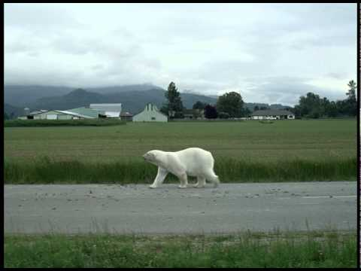
A YouTube element has been excluded from this version of the text. You can view it online here: https://pressbooks.howardcc.edu/engl087/?p=69

Activity B ~ Choosing Rhetorical Appeals
A. Check in with your partners: What’s the difference between rhetorical modes and rhetorical appeals?
B. Discuss the following topics with your partners, as we did in our chapter on rhetorical modes (patterns of organization). This time, think about which appeal(s) would be most effective for an essay about each topic. Why?
- Gender roles
- Race in America
- The value of art in society
- Travel as part of a well-rounded education
- Drugs and alcohol
- Advice to new parents
- Advice to teachers
- The value of making mistakes
- How you’d spend a million dollars
- What a tough day at work taught you about yourself or others
C. Consider the essay you are working on now. What rhetorical appeals would be most effective for your audience? Why? Discuss with your writing partners.
This chapter was modified from “Logos, Ethos, Pathos” from Developmental English: Introduction to College Composition under a CC BY-SA: Attribution-ShareAlike license.
Image of Persuasion. Authored by: Mrs. Adcock. Located at: https://agi241classes.wikispaces.com/Fifth+Grade. Project: Computer Class AGI241. License: CC BY-SA: Attribution-ShareAlike
Note: links open in new tabs.

PART IV

Big Issues
College writing demands that we examine our ideas and beliefs with an open mind. We use the metacognitive skills, information literacy skills, and critical thinking skills that are described in the following section to elevate our work and communicate effectively.

Chapter 20

Metacognition

“
” by
is licensed under
Metacognition means “thinking about thinking,” How do you apply this skill to your academic writing habits? By thinking about what works and what doesn’t work for you as a writer, and reflecting on what you have learned after each writing assignment, you can improve your academic writing skills. Being aware of how you are learning, and what strategies work well for you, can help you succeed in all of your courses.
Consider the following lists of questions from one of the ENGL 099 texts:

Reflecting as a Writer
As a writer, reflecting will help you pay attention to your progress, your struggles, your strengths, and your weaknesses. Additionally, by considering different assignments and tasks (in this class and across classes) you will be more likely to transfer your learning and find similarities across assignments that help you to be more prepared and more confident.
To be useful, any reflective or metacognitive assignment should be something you take your time with. You should try to consider specific details when you’re thinking about a project, so that you notice things about yourself:
- What habits are you relying on or developing? Are they good or bad habits? What do these do for your writing process? Why? How?
- How are you able to apply class lessons to work when you’re outside of class?
- What kinds of similarities or differences can you recognize among writing assignments?
- How have you improved since the last assignment? How are you growing as a writer?
- Are you fully understanding the texts that you read? How do you know? How are you able to apply them to your writing?
- ​​What is your writing process? How does that process affect your writing overall?
- Where and when do you feel “stuck” as a writer?
Once you start recognizing patterns, hiccups, problems, solutions, and good questions to ask yourself, you’ll be more involved in your learning – and you’ll be better prepared to tackle more challenging assignments. Remember: learning takes time. Everyone has to struggle through difficult tasks. What matters in the end is that we can look back and see how we were able to conquer those challenges – what tools we used and what strategies we employed.

Activity A ~ Metacognition & Reflection on a Past Assignment
Think about an assignment from your past that was challenging for you. It doesn’t matter if you felt you completed a successful or unsuccessful final product; instead, consider why the assignment was difficult.
1. Make a list of the struggles you had. Why was this particular assignment hard?
- What was the nature of the assignment? Is that part of the reason you struggled? Why?
- What materials were being covered? How did you respond or react to that?
- How did you manage your time and other classwork to make time to work on the assignment?
- Did you put in a lot of effort?
- Were you unable to get engaged?
2. Which of these factors had an impact on your ability to complete the assignment?
3. Now consider: which of these factors do you have the most control over? How can you overcome similar struggles should you face them during this semester?
4. Write a reflection (a detailed, personal response) on what you’ve learned about yourself from answering these questions. What should you watch out for when you have another challenging assignment? What will help you succeed?

Actviity B ~ Resilience: Read & Reflect
Read “How Resilient Are You?” from The New York Times.
- Discuss the questions at the end of the article with your partners.
- Write a short composition to give advice to others facing difficult situations.

For more information about strategies for success in college, watch “
‘” by Stephen Chew from Samford University. At about minute 4:00, Professor Chew explains more about metacognition.
The Reflecting as a Writer portion of this chapter, and the Metacognition activity, were adapted from “Metacognition” from Engaging Texts: An Introduction to College Reading and Writing.
- Revision and Adaptation. Provided by: Lumen Learning. License: CC BY: Attribution
- Writing Strategies. Provided by: Lumen Learning. Located at: https://courses.candelalearning.com/lumencollegesuccess/chapter/writing-strategies/. License: CC BY: Attribution
Note: links open in new tabs.

Chapter 21

Information Literacy: Evaluating Information
Having information literacy skills means knowing how to find and use outside sources well. This means that you are able to locate the work of other scholars and experts (from library databases, books or journals, or from outside sources like Google Scholar) and incorporate them into your own work. Using your information literacy skills means that you know how to choose sources wisely, and how to evaluate whether a source is “good” or “bad.” It also means that you value academic honesty, and that you are careful about providing attribution via in-text citations and a Works Cited list whenever you use other people’s ideas.
The three sections below provide useful information about using outside sources responsibly.

A. How do you know if your sources are “good”? Ask yourself the questions on this checklist for Evaluating Information from our HCC library:

Evaluating Information

The CRAAP test is a set of criteria to help evaluate information sources:
Criteria | Details
Currency
Relevancy
Authority
Accuracy
Purpose

B. When using websites, we need to be especially careful to ensure that we are looking at reliable information. Use this checklist for Evaluating Websites, also from our HCC library, to help you make decisions about possible sources:

Evaluating Websites: Evaluating Information Checklist

Here are some basic questions categorized in three sections to help you understand and evaluate the credibility of a website.
The Author

Is the author, whether a single person or a group of people, an expert?
Is there a way to contact the author(s) for more information or to verify who they are?
Does the author use real, checkable facts to support his or her opinions?
Does the author use neutral language, regardless of his or her opinion about the subject?

The Website

Does the page have a .edu, .org, or .gov ending in its URL?
Is there a date that shows when the page was last updated?
Is the page complete, containing no broken links or “under construction” pages?
Is the page well designed and easy to navigate, without too much scrolling or clicking?
Is this information published elsewhere in hardcopy, such as in a newspaper or journal?
Is the content of the page well written, with few grammar and spelling mistakes?

You

Is this site appropriate for your needs?
Did you make a checklist of what a reliable site about your topic would be like?
Will your instructor be impressed when s/he sees this site in your works cited list?
Have you looked at at least 5 sites about this topic?

C. Do you prefer to listen and learn? Listen to this video about “5 Ways to Evaluate Information” from HCC’s librarians.

Chapter 22

Critical Thinking for Academic Writing in the U.S.

Questions to Ponder
With your partner, brainstorm a list of words that you think of when you hear the phrase “critical thinking.” What does critical thinking mean to you? How do you use critical thinking in your daily life? in college?

Analysis and Reflection in Critical Thinking
In this course, you will need to think critically about the topics you are writing about. College essays often require analysis and reflection about a topic, in addition to explanations of facts about the topic. And when you conduct research to find facts, you also need to think critically about what you discover. You need to use your skills of logical reasoning as you consider your perspective on the topic. You also need to keep an open mind, because you may change your opinion as you do your research. Good writing helps us discover our ideas and opinions. It can help us change other people’s minds, but first, we have to be open to changing our own minds.
When you have an essay assignment, you need to think critically about the prompt. What is the professor asking? Who is the audience? What is your purpose for this essay? What type of rhetorical mode(s) would be best to use in this essay? Where do you need to look for support for your ideas? What type of rhetorical appeals (pathos, ethos, logos) would be most effective?
As you begin your research, you need to use critical thinking skills. This means that you should read carefully, watching for authors’ biases, and that you should select sources that pass the tests for credibility, relevancy, accuracy, authority, and purpose. Do not accept everything you read as true or accurate; instead, carefully consider assumptions and opinions in what you read.
Here is one set of questions to ask to improve your critical thinking skills as you conduct scholarly research:
- What’s happening? Gather the basic information and begin to think of questions.
- Why is it important? Ask yourself why it’s significant and whether or not you agree.
- What don’t I see? Is there anything important missing?
- How do I know? Ask yourself where the information came from and how it was constructed.
- Who is saying it? What’s the position of the speaker and what is influencing them?
- What else? What if? What other ideas exist and are there other possibilities?
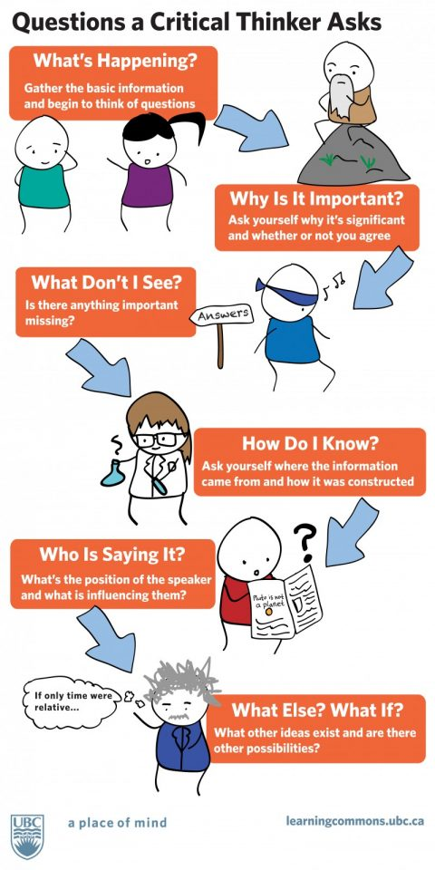
Questions and figure from “Critical Thinking” from Lumen’s Introduction to College Composition: Thinking Critically.
: UBC Learning Commons.
: The University of British Columbia, Vancouver Campus.
:
.
:

PART V

Appendices

Chapter 23

Keyboarding Practice Sites
For more help with keyboarding skills, visit these free websites:
LearnTyping
Typeracer

Note: links open in new tabs.

Chapter 24

MLA Formatting Guides

Using MLA to Format Your Documents
The following are the basic guidelines for setting up an MLA-formatted document. Your word processor will have menu controls to help you with these settings.
- Set side margins to 1” on left, right, top, and bottom.
- Set margins to 0.5” for header and footer.
- Use a standard* 12-point font throughout the document.
- Double-space throughout the document.
- Use a straight left edge and a “ragged” right edge.
- Indent paragraphs ½” (1 tab).
- Center a document title on page 1. Use plain 12-point font—do not bold, underline, or italicize.
- Create an upper left heading on page 1 only. This should include the following:
  - Your name (first and last name)
  - Your instructor’s name
  - The name of the class
  - The date, in MLA style**

- Create an upper right header for all pages. This should include the following:
  - Your last name
  - An automatic page number

*Examples of standard fonts include Times, Times New Roman, Arial, Helvetica, and others. Avoid non-standard Microsoft fonts like Calibri and Cambria, typewriter fonts (Courier), and overly-casual fonts (Comic Sans and Papyrus). Your instructors may also specify fonts that they prefer.
**MLA date format is very specific: it includes, in this order, the day of month, month, and year.
For example, the day February 11 in the year 2020 would look like this: 11 February 2020.
Longer months can also be abbreviated, so it could also look like this: 11 Feb. 2020.
Note that there are no commas in an MLA-style date.
Use this format for your document heading and on your Works Cited list. When mentioning dates in your paper, use traditional U.S. format, i.e., “On February 11, 2020, I found the world’s best coffee shop.”
Consult this example of what the beginning of of an MLA-formatted paper looks like, from mla.org. For additional examples, visit Sample Papers in MLA Style.

A Four-Step Process for Working with Sources
1: Create a Works Cited Page. When you bring a source into to your writing, create a Works Cited page and immediately add your source to the page, creating a complete, correct listing.
2: Use Sources Correctly. Bring written sources into your paper using quotation, paraphrase, or summary.
3: Cite/Identify In-Text Sources. When you add a source to your paper, immediately cite or identify it where it occurs.
4: Proofread Your Work with Sources.

  - Check and double-check to make sure every sentence containing a source has been properly cited or identified.
  - Make sure Works Cited listings and in-text citations “match.” If you mention a source in your paper, it must also appear on the Works Cited list. If you mention a source on your Works Cited list, it must also appear in the paper.
Here are some excellent online resources to help you work with MLA:
The Purdue University Online Writing Lab (OWL): this site is used by educators and colleges all over the US and in other countries as well. It will help you not just with MLA but with all aspects of writing, research, grammar, usage, etc. It has an excellent search tool. It’s also updated almost continuously.
The MLA Style Center: this is a subdivision of the larger MLA website. It has great materials to help students practice with MLA. It has a downloadable copy of the MLA template, FAQ pages, and more.
MLA Practice Template: from the MLA Style Center. Use this to practice formatting your citations.
This chapter was adapted from “
” from

1

Glossary
abrupt

academic disciplines

adjacent

anecdote

ball

bladder

branch out

coach

coherence

Cohesion

common knowledge

components

conclude

condense

conduct

contemplate

contradicting

credibility

debatable

deciduous

deck themselves out

drive home

dwindling

embark

emerge

Engage

entrainment

establish

ethos

excerpt

exclusive

Exemplify

expel

Explicit

formatting

Hamilton

hedging

Implicit

imprecise

indented

inherently

initial

integral

jargon

Jot down

logos

mechanics

Omit

opposes

pathos

point of view

ponder

Preserving

prompt

proverbs

recursive

redundancy

redundant

relevant

remedy

reverse outline

revise

sparingly

Subtle

take a stand

theft

thesis

unity

unwieldy

vague

vivid

wraps up

